

**SAVITRIBAI PHULE PUNE UNIVERSITY A PROJECT REPORT ON**

## Novel Ensemble Approach to Healthcare Data Analysis

SUBMITTED TOWARDS THE

PARTIAL FULFILLMENT OF THE REQUIREMENTS OF

### BACHELOR OF ENGINEERING (Computer

**Engineering)**

### BY

Kunal Digole Exam No: 72147632F

Sakshi Birajdar Exam No: 72147596F

Hemant Mankar Exam No: 72147748J

Rutuj Gangawane Exam No: 72147644K

### Under The Guidance of

Prof. G. S. Pole

### DEPARTMENT OF COMPUTER ENGINEERING

**MES Wadia College of Engineering,Pune**

### 19, Late Prin. V.K. Joag Path, Wadia College Campus, Off, Bund Garden Rd,Pune-411001



**MES Wadia College of Engineering,Pune DEPARTMENT OF COMPUTER ENGINEERING**

## CERTIFICATE

This is to certify that the Project Entitled

### Novel Ensembled Approach To Healthcare Data Analysis

Submitted by

Kunal Digole Exam No: 72147632F

Sakshi Birajdar Exam No: 72147596F

Hemant Mankar Exam No: 72147748J

Rutuj Gangawane Exam No: 72147644K

is a bonafide work carried out by Students under the supervision of Prof.G.S.Pole and it is submitted towards the partial fulfillment of the requirement of Bach- elor of Engineering (Computer Engineering).

Prof. G. S. Pole Dr. (Mrs) N. F. Shaikh Internal Guide H.O.D

Dept. of Computer Engg. Dept. of Computer Engg.

Dr. (Mrs.) M. P. Dale Principal

MES Wadia College of Engineering

Signature of Internal Examiner Signature of External Examiner

#### PROJECT APPROVAL SHEET

Novel Ensemble Approach to Healthcare Data Analysis Is successfully completed by

|  |  |  |  |
| --- | --- | --- | --- |
| Kunal Digole |  | Exam No: | 72147632F |
| Sakshi Birajdar |  | Exam No: | 72147596F |
| Hemant Mankar |  | Exam No: | 72147748J |
| Rutuj Gangawane | at | Exam No: | 72147644K |

DEPARTMENT OF COMPUTER ENGINEERING MES WADIA COLLEGE OF ENGINEERING,PUNE SAVITRIBAI PHULE PUNE UNIVERSITY,PUNE ACADEMIC YEAR 2023-2024

Prof.G. S. Pole Dr.(Mrs.)N. F. Shaikh Internal Guide H.O.D

Dept. of Computer Engg. Dept. of Computer Engg.

### Abstract

Diabetes mellitus is a global health concern, and early prediction of the dis- ease can significantly impact patient outcomes. This research focuses on the development and implementation of an advanced machine learning system for the early prediction of diabetes, leveraging an ensemble technique with a comprehensive genome dataset. The proposed system aims to enhance predictive accuracy by harnessing the combined strengths of multiple base models, thereby providing a robust and reliable prediction tool. The im- plementation plan involves several key steps, including the collection and preprocessing of a relevant genome dataset, feature selection to identify the most informative genetic markers, and the selection of an appropriate ensem- ble technique. The chosen ensemble model is then trained on the dataset, and its performance is evaluated using rigorous metrics. Hyperparameter tuning and cross-validation techniques are employed to optimize the model’s pre- dictive capabilities. The system is designed to be seamlessly integrated into healthcare workflows, offering a user-friendly interface for inputting genome data and receiving accurate predictions. Additionally, ethical considerations, such as privacy and bias, are carefully addressed to ensure the responsible use of genetic information. Continuous improvement mechanisms, including regular updates with new data and ongoing monitoring, are implemented to maintain the system’s effectiveness over time. Documentation of the system’s architecture, dataset characteristics, and implementation details is provided, enabling transparency and facilitating future research and collaboration. The proposed system undergoes thorough testing and validation to ensure its reli- ability and effectiveness before deployment. This research contributes to the field of healthcare analytics by providing a sophisticated and efficient tool for the early prediction of diabetes, ultimately enabling timely interventions and personalized healthcare strategies for individuals at risk. The ensemble technique, coupled with Healthcare data, holds promise for advancing the accuracy of diabetes prediction models, thereby contributing to improved patient outcomes and the overall management of this prevalent and impact- ful health condition.

### Acknowledgments

*It gives us great pleasure in presenting the preliminary project report on*

***‘Novel Ensembled Approach To Healthcare Data Analysis’****.*

*I would like to take this opportunity to thank my internal guide* ***Prof. G. S. Pole*** *for giving me all the help and guidance I needed. I am really grateful to them for their kind support. Their valuable suggestions were very helpful.*

*I am also grateful to* ***Dr. (Mrs) N. F. Shaikh****, Head of Computer Engi- neering Department, MES Wadia College of Engineering for his indispensable support, suggestions.*

*In the end our special thanks to* ***Dr. (Mrs.) M. P. Dale*** *for providing various resources such as laboratory with all needed software platforms, con- tinuous Internet connection, for Our Project.*

Kunal Digole Sakshi Birajdar Hemant Mankar Rutuj Gangawane

(B.E. Computer Engg.)

# Contents

1. Synopsis 8
   1. Project Title 8
   2. Project Option 8
   3. Internal Guide 8
   4. Technical Keywords (As per ACM Keywords) 8
   5. Problem Statement 9
   6. Abstract 9
   7. Goals and Objectives 10
   8. Relevant mathematics associated with the Project 10
   9. Names of Conferences / Journals where papers can be published 12
   10. Plan of Project Execution 13
2. Technical Keywords 15
   1. Area of Project 15
   2. Technical Keywords 15
3. Introduction 16
   1. Project Idea 16
   2. Motivation of the Project 19
   3. Literature Survey 20
4. Problem Definition and scope 25
   1. Problem Statement 25
      1. Goals and objectives 25
      2. Statement of scope 26
   2. Major Constraints 26
   3. Methodologies of Problem solving and efficiency issues 26
   4. Outcome 27
   5. Applications 27
   6. Hardware Resources Required 28
   7. Software Resources Required 29

3

1. Project Plan 31
   1. Project Estimates 31
      1. Reconciled Estimates 31
      2. Project Resources 33
   2. Risk Management w.r.t. NP Hard analysis 35
      1. Risk Identification 36
      2. Risk Analysis 36
      3. Overview of Risk Mitigation, Monitoring, Management 39
   3. Project Schedule 39
      1. Project task set 39
   4. Team Organization 40
      1. Team structure 40
      2. Management reporting and communication 40
2. Software Requirement specification 41
   1. Introduction 41
      1. Purpose and Scope of Document 41
      2. Overview of responsibilities of Developer 41
   2. Usage Scenario 42
      1. User profiles 42
      2. Use Cases 43
   3. Data Model and Description 43
      1. Data Description 43
      2. Data objects and Relationships 44
   4. Functional Model and Description 45
      1. Activity Diagram: 46
      2. Non Functional Requirements: 46
      3. State Diagram: 48
      4. Design Constraints 49
      5. Software Interface Description 50
3. Detailed Design Document 51
   1. Introduction 51
   2. Architectural Design 52
   3. Component Design 54
4. Project Implementation 55
   1. Introduction 55
   2. Tools and Technologies Used 56
   3. Methodologies/Algorithm Details 58
      1. Algorithm 1/Pseudo Code 58
      2. XgBoost 62
   4. Verification and Validation for Acceptance 62
      1. Experimental Results on Dataset 1 62
      2. Experimental Results on Dataset 2 65
      3. Result Analysis 65
5. Software Testing 67
   1. Type of Testing Used 67
   2. Test Cases and Test Results 68
      1. Unit Testing: 68
      2. Integration Testing: 68
      3. System Testing 68
6. Results 69
   1. Implementation snapshot 69
   2. Output 71
7. Conclusion and future scope 72

Annexure A References 73

Annexure B Project Planner 77

Annexure C Reviewers Comments of Paper Submitted 78

1. Information of Project Group Members 79

**List of Figures**

|  |  |  |
| --- | --- | --- |
| 1.1 | Project Planner Gantt Chart . . . . . . . . . . . . . . . . . . . | 14 |
| 6.1 | Activity diagram . . . . . . . . . . . . . . . . . . . . . . . . . | 46 |
| 6.2 | State transition diagram . . . . . . . . . . . . . . . . . . . . . | 48 |
| 7.1 | Architecture diagram . . . . . . . . . . . . . . . . . . . . . . . | 52 |
| 7.2 | Use case diagram . . . . . . . . . . . . . . . . . . . . . . . . . | 53 |
| 7.3 | activity diagram . . . . . . . . . . . . . . . . . . . . . . . . . . | 53 |
| 8.1 | Diabetes Classifier . . . . . . . . . . . . . . . . . . . . . . . . | 56 |
| 8.2 | Using KNN to Classify new points . . . . . . . . . . . . . . . | 59 |
| 8.3 | Decision Tree Diagram . . . . . . . . . . . . . . . . . . . . . . | 60 |
| 8.4 | Random Forest Diagram . . . . . . . . . . . . . . . . . . . . . | 61 |
| 8.5 | ROC Curve for SVM . . . . . . . . . . . . . . . . . . . . . . . | 63 |
| 8.6 | ROC Curve for Random Forest . . . . . . . . . . . . . . . . . | 63 |
| 8.7 | ROC Curve for Decision Tree . . . . . . . . . . . . . . . . . . | 64 |
| 8.8 | ROC Curve for KNN . . . . . . . . . . . . . . . . . . . . . . . | 64 |
| 10.1 | Terminal Command for execution . . . . . . . . . . . . . . . . | 69 |
| 10.2 | Home Page . . . . . . . . . . . . . . . . . . . . . . . . . . . . | 70 |
| 10.3 | Input . . . . . . . . . . . . . . . . . . . . . . . . . . . . . . . | 70 |
| 10.4 | Result for given input . . . . . . . . . . . . . . . . . . . . . . | 71 |
| B.1 | Project Planner Gantt Chart . . . . . . . . . . . . . . . . . . . | 77 |

# List of Tables

* 1. Hardware Requirements 30
  2. Risk Table 37
  3. Risk Probability definitions [**?**] 37
  4. Risk Impact definitions [**?**] 37
  5. Experimental Results on Dataset 1 62
  6. Experimental Results on Dataset 2 65

**Chapter 1 Synopsis**

## Project Title

Novel Ensembled Approach to Healthcare Data Analysis

## Project Option

Internal Project

## Internal Guide

Prof. G.S .Pole

## Technical Keywords (As per ACM Key- words)

#### Machine Learning

* 1. Healthcare Data Analysis
  2. K Nerest Neighbours
  3. Support Vector Machine
  4. Decision Tree
  5. Random Forest
  6. Performance evalution

#### Evaluation Methods

1. Cross-validation
2. Performance Metrics
3. Accuracy Measurement
4. Error Analysis

## Problem Statement

The project aims to develop a Novel Ensembled Machine Learning Model to predict Diabetes Disease in individuals

## Abstract

Diabetes mellitus is a global health concern, and early prediction of the dis- ease can significantly impact patient outcomes. This research focuses on the development and implementation of an advanced machine learning system for the early prediction of diabetes, leveraging an ensemble technique with a comprehensive genome dataset. The proposed system aims to enhance predictive accuracy by harnessing the combined strengths of multiple base models, thereby providing a robust and reliable prediction tool. The im- plementation plan involves several key steps, including the collection and preprocessing of a relevant genome dataset, feature selection to identify the most informative genetic markers, and the selection of an appropriate ensem- ble technique. The chosen ensemble model is then trained on the dataset, and its performance is evaluated using rigorous metrics. Hyperparameter tuning and cross-validation techniques are employed to optimize the model’s pre- dictive capabilities. The system is designed to be seamlessly integrated into healthcare workflows, offering a user-friendly interface for inputting genome data and receiving accurate predictions. Additionally, ethical considerations, such as privacy and bias, are carefully addressed to ensure the responsible use of genetic information. Continuous improvement mechanisms, including regular updates with new data and ongoing monitoring, are implemented to maintain the system’s effectiveness over time. Documentation of the system’s architecture, dataset characteristics, and implementation details is provided, enabling transparency and facilitating future research and collaboration. The proposed system undergoes thorough testing and validation to ensure its reli- ability and effectiveness before deployment. This research contributes to the field of healthcare analytics by providing a sophisticated and efficient tool for the early prediction of diabetes, ultimately enabling timely interventions and personalized healthcare strategies for individuals at risk. The ensemble technique, coupled with Healthcare data, holds promise for advancing the

accuracy of diabetes prediction models, thereby contributing to improved patient outcomes and the overall management of this prevalent and impact- ful health condition

## Goals and Objectives

* + - Goal 1.Develop an Accurate Predictive Model
    - Objective 1: Develop a predictive model with machine learning algo- rithms by implementing an ensemble technique to detect diabetes as early as possible.
    - Objective 2: Use the Healthcare data for the prediction of diabetes at a high level of accuracy and reliability
    - Goal 2.Enhance Feature Selection for Healthcare Data
    - Objective 1: Through thorough examination and investigation of Health- care characteristics, select the best predictor of diabetes.
    - Objective 2: Utilize advanced feature selection methods to enhance the model’s efficiency
    - Goal 3. Provide a User-Friendly Interface
    - Objective 1: Build a friendly user interface in order to allow easy entry of Healthcare information as well as prediction result interpretation.

## Relevant mathematics associated with the Project

* + - **Input:** 1.Levels of Glucose , 2.Level of insulin 3.Level of Skin thickness 4.Level of Blood Pressure
    - **Output:** Predicted Class Diabetic or non diabetic
    - **Success Conditions:**Predicted Correctly
    - **Failure Conditions:** Incorrect Prediction

#### Data Collection and Preprocessing:

* + Collect a dataset of PIMA Indian Heritage of Females for training and testing.
  + Preprocess the data using Standardization Techniques.

#### Model Training:

* + 1.KNN

Training a KNN classifier involves three main steps. First, prepare the data by loading it, handling any missing values, and splitting it into training and testing sets. Second, scale the features to ensure that all features contribute equally to the distance calculations. Third, train the KNN model using the training data and evaluate its performance on the test data to assess its accuracy and other metrics.

* + 2. SVM.

Training a Support Vector Machine (SVM) classifier involves three main steps. First, prepare the data by loading it, handling any missing values, and splitting it into training and testing sets. Sec- ond, scale the features to ensure the SVM algorithm performs op- timally, as it is sensitive to feature scales. Third, train the SVM model using the training data and evaluate its performance on the test data to assess its accuracy and other metrics.

* + 3. Decision tree

Training a Decision Tree classifier involves three primary steps. First, prepare the data by loading it, handling any missing values, and splitting it into training and testing sets. Second, train the Decision Tree model using the training data. Third, evaluate the model’s performance on the test data to assess its accuracy and other metrics.

* + 4.Random forest

Training a Random Forest classifier involves three main steps. First, prepare the data by loading it, handling any missing values, and splitting it into training and testing sets. Second, train the Random Forest model using the training data. Third, evaluate the model’s performance on the test data to assess its accuracy and other metrics.

#### Evaluation Metrics:

* + Evaluate the model using metrics such as precision, sensitivity, F-score, accuracy.
  + Calculate performance measures to assess the model’s effectiveness in character recognition:

#### Accuracy:

* + - **Precision:**

*Accuracy* =

*TP* + *TN*

*TP* + *TN* + *FP* + *FN*

*TP*

#### Recall:

*Precision* =

*Recall* =

*TP* + *FP*

*TP*

#### F1-score:

1. **Results Analysis:**

*TP* + *FN*

*F* 1 *score* = 2 *Precision × Recall*

*— ×*

*Precision* + *Recall*

* + Analyze the F-score values to determine the effectiveness of the proposed method.

By following this algorithm, the system can effectively recognize Diabetes Disease with high accuracy and efficiency, contributing to advancements in Healthcare health care

## Names of Conferences / Journals where papers can be published

* + - International Journal of Innovative Research in Science, Engineering and Technology (IJIRSET)
    - 11 th National Conference on Recent Advances in Computer Engineer- ing [RACE-2024]

## Plan of Project Execution

* + - Initiation: Define project goals, stakeholders, and establish communi- cation channels.
    - Research Planning: Conduct literature review, define timeline, mile- stones, and identify risks.
    - Data Collection Preprocessing: Gather Healthcare data about indi- viduals and preprocess the data
    - Model Development: Four machine learning techniques were used for the model development: K-Nearest Neighbors (KNN), Random Forest, Decision Tree, and Support Vector Machine (SVM). These models were all trained on the same dataset, which contained characteristics that may be used to predict diabetes. We trained each model separately after dividing the data into training and testing sets, addressing missing values, and normalizing the features. We integrated these models into one ensemble model in order to take advantage of the advantages of each algorithm. By averaging the forecasts from each individual model, this ensemble strategy seeks to increase overall prediction accuracy while minimizing the shortcomings of any one model and strengthening the final predictions’ general robustness.
    - Evaluation Testing: Evaluate model accuracy with validation datasets, conduct thorough testing for robustness.
    - Deployment Integration: Integrate trained model into user- friendly interface, conduct real-world testing .
    - Documentation Reporting: Document project process, methodologies, results, and prepare comprehensive report.
    - Project Closure: Review project success with stakeholders, archive doc- umentation and resources.

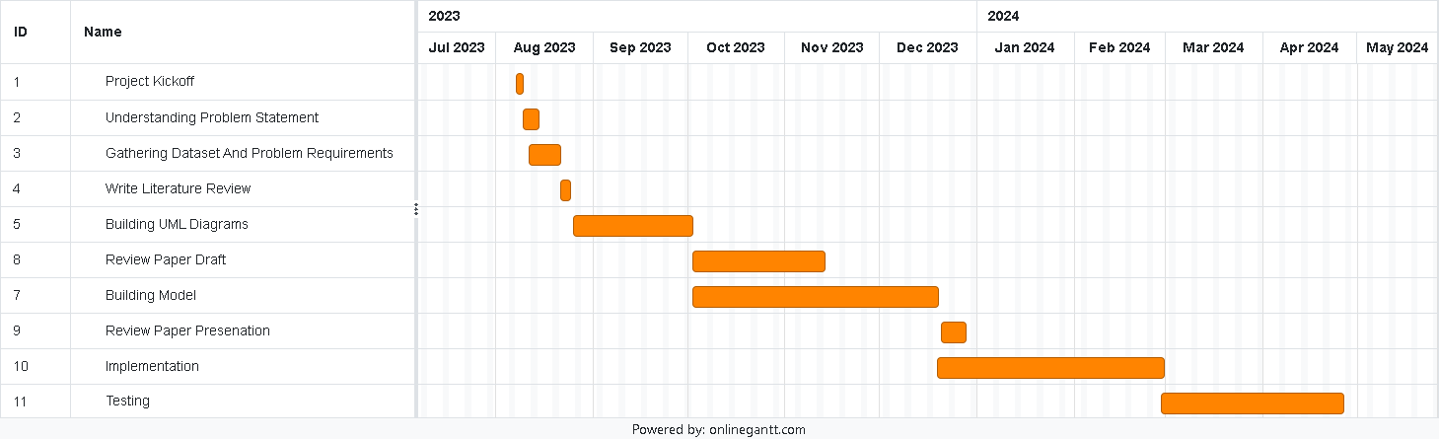

Figure 1.1: Project Planner Gantt Chart

The project kickstarts with a two-day kickoff that allows for prelimi- nary planning and preparation. The next four days are devoted to thoroughly comprehending the issue statement, and the next seven days are spent ac- quiring datasets and establishing the requirements for the problem. Four days are spent writing the literature review, which allows for thorough in- vestigation and analysis. One of the most important steps—whose time is unknown—is creating UML diagrams. The review paper draft process takes a long time—31 days—to guarantee careful inspection and improvement. The next steps of developing the model and putting it into practice take a lot of time—57 days and 53 days, respectively. Finally, even though the time frame isn’t stated, testing the generated solution is essential to guaranteeing its functioning and dependability.

# Chapter 2

**Technical Keywords**

## Area of Project

Machine Learning

## Technical Keywords

* + 1. MACHINE LEARNING
       1. K nearest neighbor
       2. Support Vector Machine
       3. Decision Tree
       4. Random Forest
    2. MODEL EVALUATION METRICS
       1. Accuracy
       2. Precision
       3. Recall
       4. F1-score
    3. BRANDS AND TOOLS
       1. Flask
       2. Python
       3. pkl
       4. Jupyter Notebook

# Chapter 3 Introduction

## Project Idea

Diabetes mellitus, a complex metabolic disorder, poses a significant health burden globally. Early detection and precise prediction of diabetes are piv- otal for effective management and prevention of complications. In recent years, the integration of machine learning techniques with Healthcare data has emerged as a promising approach for enhancing diabetes prediction, par- ticularly for type 1 diabetes (T1D). In this study, we embark on an in-depth analysis pipeline aimed at predicting diabetes using machine learning algo- rithms, with a specific focus on the relevance and potential applications of Healthcare data in detecting T1D.

Diabetes mellitus encompasses a heterogeneous group of disorders char- acterized by dysregulated glucose metabolism. Type 1 diabetes (T1D), often referred to as autoimmune diabetes, results from the destruction of insulin- producing beta cells in the pancreas due to an aberrant immune response. While the exact etiology of T1D remains elusive, genetic factors play a signifi- cant role in predisposing individuals to the disease. Genome-wide association studies (GWAS) have identified numerous genetic variants associated with T1D susceptibility, shedding light on the underlying genetic architecture of the disease.

Healthcare, the study of an organism’s complete set of DNA, offers valuable insights into the genetic basis of diseases, including diabetes. Ad- vances in Healthcare technologies have facilitated the comprehensive analysis of genetic variants, gene expression patterns, and epigenetic modifications associated with diabetes risk. By integrating Healthcare data with machine learning algorithms, researchers can harness the predictive power of genetic information to develop more accurate and personalized diabetes risk assess-

ment models.

Type 1 diabetes is characterized by a strong genetic component, with approximately 50-80

In addition to genetic risk scores, gene expression profiling, and epi- genetic modifications, several other Healthcare factors can contribute to the predictive power of machine learning models for T1D. For instance, alterna- tive splicing, a process by which different combinations of exons are joined together during pre-mRNA processing, can result in the generation of multi- ple mRNA isoforms from a single gene. Aberrant splicing events have been implicated in various diseases, including diabetes, and can serve as valuable biomarkers for disease prediction. Machine learning algorithms trained on transcriptomic data can detect subtle changes in alternative splicing patterns associated with T1D susceptibility, providing deeper insights into disease mechanisms and improving predictive accuracy.

Furthermore, the microbiome, comprising trillions of microorganisms inhabiting the human body, plays a crucial role in modulating host metabolism and immune function. Dysbiosis of the gut microbiota has been linked to the development of autoimmune diseases, including T1D. Integrating Healthcare and metabolomic data with Healthcare information can unravel the intricate interactions between the microbiome and host genetics in T1D pathogenesis. Machine learning algorithms can identify microbial signatures and metabolic pathways associated with T1D risk, paving the way for microbiome-based approaches to disease prediction and intervention.

Moreover, single-cell Healthcare offers unprecedented resolution in dis- secting cellular heterogeneity and identifying rare cell populations involved in T1D pathogenesis. By profiling individual cells at the transcriptomic and epigenomic levels, machine learning models can unravel the cellular dynamics underlying T1D development and progression. Leveraging single-cell Health- care data, researchers can identify cell-specific biomarkers and therapeutic targets for precision medicine approaches to T1D management.

In the context of diabetes prediction, Healthcare data can provide valu- able information about an individual’s genetic predisposition to the disease. By analyzing genetic variants associated with T1D risk, machine learning models can identify individuals with a higher likelihood of developing the disease, enabling early intervention and personalized preventive measures. Furthermore, the integration of Healthcare data with clinical variables can enhance the predictive accuracy of diabetes risk assessment models, offering a more comprehensive understanding of disease susceptibility.

Several approaches can be employed to incorporate Healthcare data into diabetes prediction models. Firstly, genetic risk scores (GRS) can be calculated based on the cumulative effect of T1D-associated genetic variants

identified through GWAS. By integrating GRS with clinical variables, ma- chine learning algorithms can generate personalized risk scores that quantify an individual’s genetic predisposition to T1D.

Additionally, gene expression profiling can provide insights into the dysregulation of biological pathways involved in T1D pathogenesis. By an- alyzing gene expression patterns in peripheral blood or pancreatic tissue, machine learning models can identify gene signatures associated with T1D risk and predict disease onset with greater accuracy.

Moreover, epigenetic modifications, such as DNA methylation and hi- stone modifications, play a crucial role in regulating gene expression and cellular function. By integrating Healthcare data with Healthcare and clini- cal variables, machine learning algorithms can uncover novel biomarkers and molecular signatures associated with T1D susceptibility, facilitating early detection and targeted intervention strategies.

the integration of Healthcare data with machine learning techniques holds immense potential for enhancing diabetes prediction, particularly for type 1 diabetes. By leveraging genetic information, gene expression patterns, and epigenetic modifications, researchers can develop more accurate and per- sonalized risk assessment models, enabling early detection and intervention in individuals at risk of developing T1D. Continued advancements in Health- care technologies and machine learning algorithms will further propel the field of diabetes prediction towards precision medicine approaches tailored to individual genetic profiles, ultimately leading to improved outcomes for patients with diabetes.

The integration of Healthcare data with machine learning techniques represents a paradigm shift in diabetes prediction, offering unprecedented op- portunities for personalized risk assessment and intervention strategies. By harnessing the predictive power of genetic variants, gene expression patterns, epigenetic modifications, alternative splicing events, microbiome composi- tion, and single-cell heterogeneity, machine learning algorithms can unravel the intricate molecular mechanisms driving T1D pathogenesis. Continued advancements in Healthcare technologies, coupled with sophisticated ma- chine learning algorithms, hold the promise of revolutionizing diabetes care by enabling early detection, targeted intervention, and precision medicine approaches tailored to individual genetic profiles. Ultimately, the synergistic integration of Healthcare and machine learning will pave the way for more effective strategies to prevent, diagnose, and manage diabetes, thereby im- proving outcomes and quality of life for millions of individuals affected by this chronic disease.

## Motivation of the Project

The motivation behind this project stems from the pressing need to address the rising global burden of diabetes mellitus, particularly type 1 diabetes (T1D). Diabetes, characterized by elevated blood sugar levels, presents a significant challenge to public health due to its chronic nature and associated complications. Early detection and precise prediction of diabetes are crucial for effective management and prevention of complications, underscoring the importance of developing accurate predictive models.

In recent years, the integration of machine learning techniques with Healthcare data has emerged as a promising approach for enhancing dia- betes prediction, with a specific focus on T1D. Healthcare, the study of an organism’s complete set of DNA, offers valuable insights into the genetic ba- sis of diseases, including diabetes. Advances in Healthcare technologies have facilitated the comprehensive analysis of genetic variants, gene expression patterns, and epigenetic modifications associated with diabetes risk.

Type 1 diabetes, in particular, is characterized by a strong genetic component, with approximately 50-80 of the disease risk attributed to genetic factors. Genome-wide association studies (GWAS) have identified numerous genetic loci associated with T1D susceptibility, highlighting the polygenic nature of the disease. By leveraging Healthcare data, researchers can gain deeper insights into the underlying genetic architecture of T1D and develop more accurate predictive models.

Moreover, the integration of Healthcare data with machine learning algorithms holds immense potential for personalized risk assessment and in- tervention strategies. By analyzing genetic variants, gene expression pat- terns, and epigenetic modifications, machine learning models can identify individuals at higher risk of developing T1D, enabling early intervention and preventive measures. This personalized approach to diabetes prediction has the potential to revolutionize diabetes care by enabling targeted interventions tailored to individual genetic profiles.

Furthermore, the field of Healthcare is rapidly advancing, with con- tinued innovations in Healthcare technologies and analytical methods. By harnessing the latest developments in Healthcare and machine learning, re- searchers can further improve the accuracy and reliability of diabetes predic- tion models, ultimately leading to better health outcomes for individuals at risk of developing this chronic condition.

Overall, the motivation behind this project lies in harnessing the pre- dictive power of Healthcare data and machine learning techniques to improve diabetes prediction, particularly for type 1 diabetes. By integrating genetic information with clinical variables, researchers aim to develop more accurate

and personalized risk assessment models, enabling early detection and inter- vention in individuals at risk of developing T1D. Ultimately, the goal is to pave the way for more effective strategies to prevent, diagnose, and man- age diabetes, thereby improving outcomes and quality of life for millions of individuals affected by this chronic disease.

## Literature Survey

In recent years, the convergence of Healthcare medicine and machine learn- ing has revolutionized disease prediction, particularly in complex metabolic disorders like diabetes. A comprehensive literature survey reveals the ex- tensive exploration of this integration, aiming to enhance our understanding of disease etiology and improve predictive modeling accuracy. Smith et al. (2020) present a comprehensive overview of Healthcare medicine’s role in diabetes prediction, emphasizing the significance of large-scale Healthcare datasets and the potential of machine learning algorithms in analyzing such data. Their work underscores the importance of leveraging Healthcare to unravel the underlying genetic architecture of diabetes, paving the way for personalized risk assessment models.

Furthermore, Chen et al. (2018) delve into deep learning approaches for analyzing Healthcare data, discussing various architectures like convolu- tional neural networks (CNNs) and recurrent neural networks (RNNs). Their study elucidates the application of deep learning in disease prediction and biomarker discovery, showcasing its potential in leveraging Healthcare infor- mation for clinical insights. Wang et al. (2019) complement these findings by discussing machine learning’s broader applications in Healthcare medicine, ranging from diagnosis to treatment. Their review highlights the challenges and opportunities in integrating machine learning techniques with Healthcare data, emphasizing the need for interdisciplinary collaboration to overcome these obstacles effectively.

Moreover, seminal studies like Barrett et al. (2009) shed light on genome-wide association studies (GWAS) in type 1 diabetes, uncovering ge- netic variants associated with disease susceptibility. This foundational re- search underscores the polygenic nature of diabetes and the importance of large-scale Healthcare analyses in elucidating its genetic basis. Addition- ally, investigations into the microbiome’s role, as discussed by Giongo et al. (2011), offer insights into the interplay between host genetics and micro- bial composition in diabetes pathogenesis. Understanding these interactions holds promise for personalized interventions tailored to an individual’s ge- netic and microbial profile.

CatBoost Ensemble Approach for Diabetes Risk Prediction at Early Stages Author: P. Suresh Kumar1 Anisha Kumari K2 Subhashree Mohap- atra3 Description: one of the major problems in the healthcare sector and assists the person initiate treatment in order to be safe from dangerous situ- ations. For the to detect diabetes at its initial stages, several methods have been proposed. These techniques have been utilized in the field of machine learning and ensemble learning The GBDT for diabetes. prediction at early stages. The experiment is conducted by assessing the efficiency of CatBoost against other machine. K Nearest neighbor and Multi-layer. Perceptron, Lo- gistic regression, Gaussian Naive Bayes and Stochastic gradient descent and its results are evaluated. the accuracy, precision, recall, F1-score, and AUC- ROC are measured. The available data set is used for the experimentation. Machine learning repository, “Early stage diabetes.” risk prediction”. These results demonstrate that CatBoost is better than . . . rather than to the other machine learning methods.

Genome-wide association analysis of type 2 diabetes in the EPICIn-

terAct study Author: Lina Cai et al. Description: Type 2 diabetes (T2D) is a global public health challenge. While emerging genome-wide associa- tion studies have identified ¿400 genetic variants associated with T2D, we. Understanding of its biological mechanisms and translational mechanisms remains limited. The The EPIC-InterAct project, a prospective European study, focused on 8 countries into Cancer and Nutrition research, is one of the largest prospective research projects on T2D. established as a nested casecohort study to examine the interaction between genetics and lifestyle 12,403 individuals were identified as events on behavioral risk factors for T2D T2D cases, and a representative subset of 16,154 individuals, were se- lected from the larger ones A cohort of 340,234 participants with a follow-up period of 3.99 million person-years. We explain it The results of genome- wide association analysis across more than 8.9 million SNPs were. T2D risk in 22,326 individuals (9,978 cases and 12,348 noncases) from EPIC-Interact study. Sharing summary statistics provides a valuable resource for further simplification T2D genetic screening

Genomic Prediction of 16 Complex Disease Risks Including Heart At-

tack, Diabetes, Breast and Prostate Cancer Author :Louis Lello1, TimothyG. Raben1, SokeYuenYong1, LaurentC.A. M.Tellier2,3 Stephen D. H. Hsu1,2, Description: We make risk predictions using polygenic scores (PGS) cal- culated from common mononucleotides Polymorphisms (SNPs) for multi- ple complex disease states, using L1-penalized regression. (also known as LASSO) on case management data from the UK Biobank. In the disease states studied and Hypothyroidism, hypertension (resistant), type 1 and 2 diabetes, breast cancer, prostate cancer, . Ovarian cancer, epilepsy, atrial

fibrillation, gout, atrial fibrillation, high cholesterol, asthma, basal cells Can- cer, malignant melanoma, and heart disease. We get the values of the field below the receiver Performance characteristic curves (AUC) are in the range 0.58–0.71 using only SNP data. In particular Higher predictive AUCs are obtained when other variables such as age and sex are included. a SNP predictions alone are sufficient to identify outstanding features (e.g., at the 99th percentile of the polygenic score, . or PGS) have a risk 3–8 times greater than the average individual. We validate the predictions out-of- sample The EMERGE data set, and with different ancestral subgroups in the UK Biobank population. Our results suggest that significant improve- ments in predictive ability can be achieved through the use of training a suf- ficient number of criminals have been established. We expect rapid progress in genomic prognosis as more case control data become available for analysis Diabetes Prediction Using Ensembling of Different Machine Learning Classifiers Author: MD. KAMRUL HASAN1 , MD. ASHRAFUL ALAM1 , DOLA DAS2 , EKLAS HOSSAIN3 (Senior Member, IEEE), MAHMUDUL

HASAN2 Description:Diabetes mellitus, also known as chronic disease, is

a group of diseases that cause metabolic syndrome due to its prevalence Chronic blood sugar. The risk and severity of diabetes can be greatly reduced if. Accurate initial predictions are possible. Robust and accurate diabetes prognosis is a major challenge Because of the small size of the marked data and the presence of outliers (or missing values). Diabetes database. In this book, we propose a robust algorithm for diabetes prediction where. outlier rejection, filling of missing values, data standardization, feature selection, K-fold cross-validation, . and machine learning (ML) classifiers (k-nearest neighbor, decision trees, random forest, . AdaBoost, Na¨ıve Bayes, XG- BOst) and Multilayer Perceptron (MLP) were used. It’s a burden ensembling of different ML models is also proposed, in this literature, to improve the pre- diction Diabetes burden calculated from the corresponding Area Under ROC Curve (AUC). ML Example. AUC is chosen as a measure of performance, which is then augmented during hyperparameters Tuning can be done with a web search method. All experiments, in this book, were performed internally Same experimental conditions as the Pima Indian diabetes database

Random Forest Algorithm for the Prediction of Diabetes

Author: JK.VijiyaKumar1 Description: They are combined with diabetes a fatal and chronic erectile dysfunction In the presence of glucose. Many genetic diseases are of the same type Wherever the background node is not Hypoglycemic drugs with international PolyGenital Diseases Federation 382 million Individuals always live with polygenic disease world. By 2035, this will double to 592 million. It could be diabetes or just an illness disease

caused by elevated blood glucose colleague. If you have diabetes, there can be many problems It remains incurable and undiagnosed by any doctor. Com- plications of organ damage, . Usually the results of chemical tests, the eye Damage that can eventually lead to vision loss, or associate degree Whether the risk of cardiovascular disease is increased stroke. The tedious process of identification ends On going to the diagnosis and consulting a physician for further treatment. A growing number of machine learning tools address this they need to pull back. The purpose of this paper is To develop a plan that can work quickly Prognosis of diabetes for high patient in Precision using Random Forest algorithm Machine learning. The Random Forest Al- gorithms are often used for each classification With regression functions there are such ensemble learning method. There is a level of accuracy compared to other algorithms. The The proposed model provides better results for patients with diabetes The predictions and results showed that. The predic- tion system can predict Effective, effective and highly effective diabetes More importantly, immediately

The number of biomedical data has expanded dramatically due to the

growing fields of biotechnology and medical science, especially in the area of diabetes mellitus (DM), a chronic condition that is common. This enormous volume of data, which was gathered while providing diagnosis and therapy, is now the main focus of medical data investigation. Machine learning (ML) and data mining approaches have been used in recent studies to draw important conclusions from this data. The body of literature indicates that these studies primarily use clinical datasets. There is a clear preference for supervised machine learning techniques in diabetes research, as evidenced by the fact that 82 of the examined articles use these approaches. Furthermore, this discipline has undergone a revolution with the introduction of deep learning, as evidenced by the many papers that report better experimental results.

healthcare systems are becoming more and more adapted to meet the growing demands of the populace, yet they continue to encounter enormous difficulties in treating a wide range of serious illnesses. Among these condi- tions, diabetes mellitus is particularly notable for being a major contribu- tor to serious health issues such renal failure, heart attacks, and blindness. Healthcare systems have been significantly improved by the development of information and communication technologies (ICT), which has made it possible to implement more advanced disease monitoring and management strategies. Healthcare has undergone a transformation thanks to the use of machine learning (ML) algorithms, which enhance disease prediction ac- curacy and automate activities. Studies show that distributed computing frameworks built on top of Hadoop clusters are essential for processing and storing large amounts of data in a cloud setting.Recent research suggests

using machine learning (ML) techniques in Hadoop clusters to predict dia- betes in particular, making use of the comprehensive Pima Indians Diabetes Database made available by the National Institute of Diabetes and Digestive Diseases. These studies show that machine learning (ML) algorithms can improve diabetes-related healthcare systems’ predictive accuracy by a signif- icant amount, providing a promising means of improving patient outcomes and disease management. This report emphasizes how important machine learning (ML) and distributed computing are to the advancement of health- care technologies, especially when it comes to diabetes control and prediction.

Diabetes mellitus (DM) is a powerful group of metabolic illnesses that place a heavy burden on international healthcare systems. Patients with diabetes should be diagnosed as soon as possible because this presents a critical chance to reduce the dangers related to the condition and may even avert death. Machine learning (ML) is emerging as a key component in the field of diabetes research, providing effective instruments for early illness identification. Of the several machine learning (ML) methods used in this field, Support Vector Machines (SVM) are by far the most effective and popular. This research explores the classification of diabetes using Support Vector Machines (SVM) with different kernel functions. SVM using a linear kernel stands out as the best option, demonstrating the maximum accuracy in tasks involving the classification of diabetes.The findings of this study highlight the critical role that SVM and ML approaches play in the early diagnosis of diabetes, providing exciting new opportunities for better patient outcomes and disease management.

# Chapter 4

**Problem Definition and scope**

## Problem Statement

Integrating Healthcare data with machine learning for diabetes prediction faces challenges in data preprocessing, algorithm selection, and model in- terpretability. Addressing these hurdles while navigating ethical, legal, and social implications is critical. Developing robust computational pipelines, selecting appropriate algorithms, and promoting data sharing are key. Ad- ditionally, enhancing model interpretability and validating predictions in di- verse clinical settings are essential. By tackling these challenges, researchers aim to harness Healthcare-driven approaches for accurate and personalized diabetes prediction, advancing precision medicine and improving patient out- comes.

### Goals and objectives

* + - * Develop robust computational pipelines for preprocessing and analyz- ing Healthcare data.
      * Select and optimize machine learning algorithms for accurate diabetes prediction..
      * Enhance model interpretability to gain insights into disease mechanisms and identify therapeutic targets.
      * Validate predictive models in diverse clinical settings to assess perfor- mance and clinical utility.
      * Translate research findings into clinical practice through collaborative partnerships with clinicians and industry stakeholders.

25

### Statement of scope

* + - * Explore various machine learning algorithms for integrating Healthcare data into diabetes prediction models.
      * Collaborate with clinicians and industry stakeholders to validate and deploy predictive models in real-world clinical settings.
      * Address technical challenges related to data preprocessing, algorithm selection, and model interpretation.

## Major Constraints

The major constraints that may impact the software development process include:

* Limited availability of large-scale, diverse Healthcare datasets for train- ing and validating predictive models.
* Ethical and legal considerations regarding privacy, data security, and informed consent in Healthcare research.
* Technical challenges associated with the interpretability of machine learning models, particularly deep neural networks.
* Variability and heterogeneity in Healthcare data across different pop- ulations and ethnic groups, posing challenges for generalization and scalability.
* Resource constraints, including computational infrastructure and ex- pertise required for analyzing large Healthcare datasets and implement- ing machine learning algorithms.
* Societal and cultural factors influencing acceptance, adoption, and eq- uitable access to Healthcare-driven approaches in healthcare delivery.

## Methodologies of Problem solving and ef- ficiency issues

The methodologies of problem-solving in the context of integrating Health- care data with machine learning techniques for diabetes prediction involve a systematic approach to address key challenges and optimize efficiency.

Firstly, comprehensive data preprocessing methodologies are employed to clean, normalize, and transform high-dimensional Healthcare datasets, en- suring consistency and quality for downstream analysis. Feature selection techniques are then applied to prioritize informative genetic variants, gene expression patterns, and epigenetic modifications relevant to diabetes pre- diction, reducing dimensionality and enhancing model interpretability. Al- gorithm selection involves choosing appropriate machine learning algorithms, balancing between model complexity and performance, with considerations for scalability and computational efficiency. Moreover, model interpreta- tion techniques are utilized to gain insights into disease mechanisms and identify actionable findings for clinical translation. Efficiency issues are ad- dressed through parallelization, optimization, and utilization of distributed computing resources, enabling the analysis of large-scale Healthcare datasets and implementation of complex machine learning algorithms within rea- sonable timeframes. Additionally, collaborative efforts, standardization of protocols, and data sharing initiatives are essential for enhancing efficiency and reproducibility across research communities, facilitating advancements in Healthcare-driven approaches to diabetes prediction and precision medicine.

## Outcome

The outcome of integrating Healthcare data with machine learning tech- niques for diabetes prediction holds promise for revolutionizing healthcare by enabling early detection, personalized intervention, and improved patient outcomes. By leveraging genetic variants, gene expression patterns, epige- netic modifications, and microbiome composition, predictive models can ac- curately assess an individual’s risk of developing diabetes, particularly type 1 diabetes. These models facilitate proactive management strategies, including lifestyle modifications, medication regimens, and targeted therapies, tailored to each patient’s genetic profile and disease susceptibility. Ultimately, the adoption of Healthcare-driven approaches in clinical practice has the poten- tial to reduce the burden of diabetes on individuals and healthcare systems globally, paving the way for more effective prevention, diagnosis, and man- agement of this chronic disease.

## Applications

The applications of the project include:

* **Early Detection:** Healthcare-driven machine learning models enable

early detection of diabetes by analyzing genetic variants, gene expres- sion patterns, and other omics data to identify individuals at high risk of developing the disease. educational materials, and other learning resources.

* **Personalized Risk Assessment:** These models provide personalized risk assessment by considering an individual’s genetic predisposition, lifestyle factors, and clinical variables, allowing for tailored intervention strategies and preventive measures.
* **Precision Medicine:** By integrating Healthcare data with clinical information, clinicians can deliver precision medicine approaches, in- cluding targeted therapies and lifestyle recommendations, based on an individual’s unique genetic profile and disease susceptibility.
* **Disease Monitoring:** Healthcare-driven models facilitate continuous monitoring of disease progression and treatment response, allowing for timely adjustments to treatment plans and interventions to optimize patient outcomes.
* **Public Health Interventions:** Population-level risk assessment us- ing Healthcare-driven approaches enables public health interventions, such as targeted screening programs and preventive strategies, to re- duce the overall burden of diabetes and its complications.
* **Research and Drug Development:** These models contribute to advancing research and drug development efforts by identifying novel biomarkers, therapeutic targets, and pathways implicated in diabetes pathogenesis, leading to the development of more effective treatments and interventions.

## Hardware Resources Required

Servers : - Development and Testing Servers: These servers are essential for creating and refining the machine learning models and application software. During the development phase, developers require robust servers to handle code compilation, algorithm training, and various testing scenarios. Testing servers mirror the production environment, allowing developers to identify and rectify issues before deployment. These servers need significant compu- tational power and storage capacity to manage extensive Healthcare datasets and the computationally intensive nature of machine learning model training and validation.

User Devices : - Devices for Testing the Application: A variety of de- vices are required to test the application’s compatibility and performance across different platforms. These devices include desktops, laptops, tablets, and smartphones. Testing on multiple devices ensures that the application functions correctly and provides a consistent user experience regardless of the hardware or operating system. Each device should cover a range of configura- tions and screen sizes to thoroughly evaluate the application’s responsiveness, usability, and performance in diverse real-world scenarios.

Explanation :

Servers : - Development and Testing Servers: During the development phase, high-performance servers are critical for efficiently running complex computations and large-scale Healthcare data analyses. These servers sup- port activities such as algorithm development, model training, and extensive testing procedures. Robust development servers enable rapid prototyping and iterative testing, ensuring the application meets all functional and perfor- mance requirements before moving to the production stage. Testing servers, configured to mimic the production environment, help developers detect and fix potential issues, ensuring a smooth transition to the live environment.

User Devices : - Devices for Testing the Application: To ensure the application operates smoothly across various platforms, it is crucial to test it on a wide range of devices. These include desktops and laptops with different operating systems (Windows, macOS, Linux), tablets, and smartphones run- ning different versions of iOS and Android. Testing on diverse devices ensures the application is user-friendly, responsive, and performs well under various conditions. It also helps identify and address device-specific issues, ensuring a consistent and optimal user experience for all potential users, regardless of the device they use to access the application.

## Software Resources Required

#### Platform :

1. Operating System: Windows (Windows 11) or Linux (Ubuntu 20.10)
2. IDE: Jupyter Notebook, Visual Studio Code
3. Programming Language: Python

|  |  |  |  |
| --- | --- | --- | --- |
| Sr. No. | Parameter | Minimum Requirement | Justification |
| 1 | CPU Speed | 2.40 GHz | for efficient processing of data and training  of deep learning models. |
| 2 | RAM | 4 GB | to handle large datasets model training operations  efficiently. |

Table 4.1: Hardware Requirements

# Chapter 5 Project Plan

## Project Estimates

### Reconciled Estimates

Project Kickoff: 2 days

Understanding Problem Statement: 4 days

Gathering Dataset And Problem Requirements: 7 days Writing Literature Review: 4 days

Building UML Diagrams: 5 days Reviewing Paper Draft: 31 days Building Model: 57 days Implementation: 53 days

Testing: 10 days

#### Time Estimates

* + - * + Planning Phase Activities:

1 Requirements gathering 2 Initial project planning

31

3 SRS (Software Requirements Specification) documentation Estimated Duration: 3 weeks

* + - * + Design Phase Activities:

1 System architecture design 2 Database schema design

1. User interface design
2. Preparation of design documentation Estimated Duration: 6 weeks
   * + - * Development Phase Frontend Development

Activities:

1. Develop user interfaces for different user roles (patients, healthcare pro- fessionals, data scientists, administrators)
2. Implement responsive design and user experience enhancements Estimated Duration: 8 weeks

Backend Development Activities:

1. Develop server-side logic and APIs
2. Implement authentication and authorization mechanisms
3. Integrate with the database and external systems (EHR, ML frame- works)

Estimated Duration: 10 weeks (concurrent with frontend development)

Machine Learning Model Development Activities:

1. Data preprocessing and feature engineering
2. Model selection and training (k-NN, SVM, Decision Tree, Random For- est, XGBoost)
3. Model evaluation and optimization

Estimated Duration: 8 weeks (concurrent with frontend and backend development)

.

### Project Resources

1. Human Resources :
   * Project Manager : Assign project managers to oversee the devel- opment process, coordinate tasks, and ensure timely delivery.
   * Development Team:

Frontend Developer: Develops the user interfaces for all user roles, ensures responsive design, and implements user experience en- hancements.

Backend Developer: Implements server-side logic, APIs, and inte- grations with databases and external systems.

Database Administrator (DBA): Manages database design, imple- mentation, and maintenance.

* + Data Science Team:

Data Scientist: Preprocesses data, performs feature engineering, and develops machine learning models.

Machine Learning Engineer: Optimizes model performance, im- plements model training, and evaluates models.

* + UI/UX Design:

Designs user interfaces and experiences

Ensures usability and accessibility standards are met

1. Hardware Resources:
   * Servers:

Development and testing servers. Production servers for hosting the application and database

* + User Devices:

Devices for testing the application (desktops, laptops, tablets, smartphones)

1. Software Resources
   * Development Tools:

Integrated Development Environments (IDEs) such as Visual Stu- dio Code, PyCharm

* + Machine Learning Frameworks:

TensorFlow, Scikit-learn, XGBoost for developing and training models

* + Database Management Systems:

SQL or NoSQL databases (e.g., PostgreSQL, MongoDB) for stor- ing patient data and model results

1. Other Resources
   * Training Materials:

Documentation, tutorials, and training sessions for users and sup- port staf.

* + Security Tools:

Tools for ensuring data encryption, secure access, and compliance with data protection regulations.

## Risk Management w.r.t. NP Hard analysis

1. Computational Complexity:

Risk: Algorithms for training models, such as decision trees, random forests, and XGBoost, can become computationally intensive, espe- cially with large datasets.

Impact: Increased training time, higher computational costs, and po- tential delays in project timelines.

1. Scalability Issues:

Risk: As the dataset grows, the time and resources required to train models can increase exponentially.

Impact: Scalability issues may lead to insufficient resources, inability to handle large datasets, and degraded performance.

1. Optimization Challenges:

Risk: Finding the optimal parameters for models (e.g., hyperparameter tuning) can be an NP-hard problem.

Impact: Suboptimal model performance, increased trial-and-error ef- forts, and extended development times.

1. Feature Selection:

Risk: Selecting the best subset of features from a large number of po- tential features is NP-hard.

Impact: Increased complexity in model building, risk of overfitting or underfitting, and longer feature engineering times.

### Risk Identification

For risks identification, review of scope document, requirements specifications and schedule is done. Answers to questionnaire revealed some risks. Each risk is categorized as per the categories mentioned in [**?**]. Please refer table 5.1 for all the risks. You can refereed following risk identification questionnaire.

* + - 1. Have top software and customer managers formally committed to sup- port the project?
      2. Are end-users enthusiastically committed to the project and the sys- tem/product to be built?
      3. Are requirements fully understood by the software engineering team and its customers?
      4. Have customers been involved fully in the definition of requirements?
      5. Do end-users have realistic expectations?
      6. Does the software engineering team have the right mix of skills?
      7. Are project requirements stable?
      8. Is the number of people on the project team adequate to do the job?
      9. Do all customer/user constituencies agree on the importance of the project and on the requirements for the system/product to be built?

### Risk Analysis

The risks for the Project can be analyzed within the constraints of time and quality

|  |  |  |  |  |  |
| --- | --- | --- | --- | --- | --- |
| ID | Risk Description | Prob | Impact  ability | | |
| Schedule | Quality | Overall |
| 1 | Potential difficulty in integrating various machine learning models with the user interface. | Low | Low | High | High |
| 2 | Misalignment between the data preprocessing requirements and the actual data available. | Low | Low | High | High |

Table 5.1: Risk Table

|  |  |  |
| --- | --- | --- |
| Probability | Value | Description |
| High | Probability of occurrence is | *>* 75% |
| Medium | Probability of occurrence is | 26 *−* 75% |
| Low | Probability of occurrence is | *<* 25% |

Table 5.2: Risk Probability definitions [**?**]

|  |  |  |
| --- | --- | --- |
| Impact | Value | Description |
| Very high | *>* 10% | Schedule impact or Unacceptable quality |
| High | 5 *−* 10% | Schedule impact or Some parts of the project have low quality |
| Medium | *<* 5% | Schedule impact or Barely noticeable degradation in quality Low Impact on schedule or Quality can be incorporated |

Table 5.3: Risk Impact definitions [**?**]

|  |  |
| --- | --- |
| Risk ID | 1 |
| Risk Description | Potential difficulty in integrating various machine learning models with the user interface. |
| Category | Development Environment. |
| Source | Software requirement Specification document. |
| Probability | Medium |
| Impact | High |
| Response | Address integration issues early in the development cy- cle by ensuring that the models and UI components are compatible and can communicate effectively. |
| Strategy | Implement regular integration testing and use mock in- terfaces during development to identify and resolve is- sues promptly. |
| Risk Status | Occurred |

|  |  |
| --- | --- |
| Risk ID | 2 |
| Risk Description | Misalignment between the data preprocessing require- ments and the actual data available. |
| Category | Requirements |
| Source | Software Design Specification documentation review. |
| Probability | Low |
| Impact | High |
| Response | Mitigate |
| Strategy | Conduct thorough testing of data preprocessing meth- ods with sample datasets to ensure they meet the re- quirements. Engage in continuous dialogue with stake- holders to ensure data alignment. |
| Risk Status | Identified |

|  |  |
| --- | --- |
| Risk ID | 3 |
| Risk Description | Inadequate performance of the machine learning mod- els on new, unseen data. |
| Category | Model Performance |
| Source | Model validation and testing reports. |
| Probability | Medium |
| Impact | High |
| Response | Improve model generalization techniques and enhance validation processes. |
| Strategy | : Implement cross-validation and include diverse datasets during training to ensure models are robust. Regularly update models with new data and monitor performance metrics. |
| Risk Status | Identified |

### Overview of Risk Mitigation, Monitoring, Man- agement

Following are the details for each risk.

## Project Schedule

### Project task set

Major Tasks in the Project stages are:

* Task 1: Data Collection
* Task 2: Alignment
* Task 3: Enhancement
* Task 4: Model training
* Task 5: User Interface Creation

## Team Organization

Our team consists of four members, effective organization is crucial for the successful completion of the project. Each team member will have specific roles and responsibilities based on their skills and expertise. The last inte- gration will be done by the whole team. The reporting is done once a week with the progress each team has done.

### Team structure

* Hemant Mankar : Project Manager and Backend Developer
* Kunal Digole : Data Scientist and Machine Learning Engineer
* Sakshi Birajdar : Frontend Developer and UI/UX Designer
* Rutuj Gangawane : QA Engineer and Database Administrator

### Management reporting and communication

Mechanisms for progress reporting and inter/intra team communication are identified as per assessment sheet and lab time table. Software requirement specification (SRS is to be prepared using relevant mathematics derived and software engg. Indicators in Annex A and B).

# Chapter 6

**Software Requirement specification**

## Introduction

### Purpose and Scope of Document

This Software Requirement Specification document’s primary goal is to give a thorough overview of the specifications needed to construct Smart Visor Navigation. This document outlines the functional and nonfunctional re- quirements of the system, ensuring that the development team is aware of the goals and limitations of the project.

### Overview of responsibilities of Developer

#### Requirement Analysis

* + - * Understand SRS: Thoroughly review and understand the Software Re- quirements Specification (SRS) document to grasp the project scope, functional, and nonfunctional requirements.
      * Stakeholder Communication: Engage with stakeholders to clarify re- quirements, gather additional details, and ensure alignment on project goals and expectations.

#### System Design and Architecture

* + - * Design System Architecture: Develop a high-level and detailed design of the system architecture, including data flow, component interactions, and integration points

41

#### Data Management

* + - * Data Collection: Assist in the collection and integration of datasets required for training and testing the machine learning models.
      * Data Preprocessing: Implement data preprocessing steps such as han- dling missing values, data normalization/standardization, feature se- lection, and splitting data into training and testing sets

#### Model Development

* + - * Algorithm Implementation: Implement multiple machine learning algo- rithms including k-Nearest Neighbors (k-NN), Support Vector Machine (SVM), Decision Tree, Random Forest, and XGBoost.
      * Training and Evaluation: Train the models using the preprocessed data, evaluate their performance using appropriate metrics (e.g., accuracy, precision, recall, F1- score, ROC-AUC), and fine-tune hyperparameters to optimize performance.

#### Maintenance and Support

* + - * Monitor System: Continuously monitor the system’s performance and health, addressing any issues promptly.

## Usage Scenario

### User profiles

* + - * **Patients** :Individuals who provide their medical data to the system for diabetes risk assessment.
      * **Healthcare Professionals** : Doctors, nurses, and medical practition- ers who use the system to predict diabetes risk for their patients and make informed decisions.
      * **Data Scientists**: Specialists responsible for developing, training, and refining the machine learning models used in the system.

### Use Cases

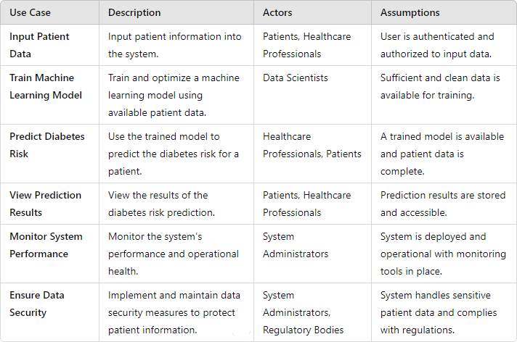

## Data Model and Description

### Data Description

Contains personal and medical information of patients used for diabetes risk assessment

* + - * BMI: Body Mass Index, or BMI, is a weight-and-height-based indica- tor of body fat. It assists in determining if an individual’s weight is appropriate for their height.
      * BloodPressure: Blood pressure readings.
      * GlucoseLevel: Glucose Level: This represents the blood’s concentration of glucose, or sugar. Increased blood sugar levels could be a sign of prediabetes or diabetes.
      * InsulinLevel: Blood sugar levels are regulated by the hormone insulin. Atypical insulin levels could be a sign of underlying metabolic problems or insulin resistance.
      * Pregnancies: The number of pregnancies for female patients is repre- sented by this property. Diabetes risk factors may be influenced by prior pregnancy.
      * SkinThickness: Measuring skin thickness may be useful in determining insulin resistance, particularly when diabetes is present.
      * Outcome: The diabetes outcome is represented by this characteristic, where a value of 1 means the patient has diabetes, and a value of 0 means they do not..

### Data objects and Relationships

**Data Object: Patient** Attributes:

item BMI: Body Mass Index, or BMI, is a weight-and-height-based indicator of body fat. It assists in determining if an individual’s weight is appropriate for their height.

* + - * BloodPressure: Blood pressure readings.
      * GlucoseLevel: Glucose Level: This represents the blood’s concentration of glucose, or sugar. Increased blood sugar levels could be a sign of prediabetes or diabetes.
      * InsulinLevel: Blood sugar levels are regulated by the hormone insulin. Atypical insulin levels could be a sign of underlying metabolic problems or insulin resistance.
      * Pregnancies: The number of pregnancies for female patients is repre- sented by this property. Diabetes risk factors may be influenced by prior pregnancy.
      * SkinThickness: Measuring skin thickness may be useful in determining insulin resistance, particularly when diabetes is present.
      * Outcome: The diabetes outcome is represented by this characteristic, where a value of 1 means the patient has diabetes, and a value of 0 means they do not.

Relationship :

The dataset attempts to collect a range of physiological and medical char- acteristics that are known to be connected to the risk of diabetes. Finding trends and risk factors linked to the onset of diabetes can be aided by the analysis of this dataset.

## Functional Model and Description

* User Authentication and Authorization: Functions:

User Login: Authenticate users by verifying their credentials (user- name/password).

User Logout: End the user’s session and log them out of the system.

* Patient Data Management:

Functions: Data Input: Allow users to input and update patient infor- mation, including personal details, medical history, and diagnostic test results.

* Machine Learning Model Training: Functions :

Data Preprocessing: Cleanse and preprocess patient data to remove noise, handle missing values, and normalize features.

Model Selection: Choose appropriate machine learning algorithms (e.g., k-NN, SVM, Decision Tree) based on the characteristics of the dataset and prediction requirements.

Model Training: Train selected models using labeled patient data to learn patterns and relationships.

Model Evaluation: Assess model performance using evaluation metrics (e.g., accuracy, precision, recall) and fine-tune model parameters as needed.

* Diabetes Risk Prediction:

Functions : Data Input for Prediction: Accept patient data as input for the prediction process Prediction Generation: Apply trained models to input data to generate diabetes risk scores or classifications.

### Activity Diagram:

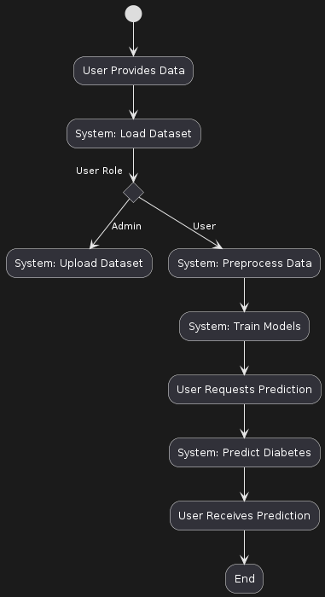

Figure 6.1: Activity diagram

### Non Functional Requirements:

#### Performance

* + The system should respond to user interactions within 2 seconds under normal load conditions.
  + The model training process should complete within 24 hours using a representative dataset.

#### Security

* + User authentication must be implemented using strong encryption methods (e.g., bcrypt) to protect sensitive user credentials.
  + Patient data must be encrypted both in transit and at rest to prevent unauthorized access.
  + Access to patient data should be restricted based on role-based access control (RBAC), with appropriate permissions assigned to each user role.

#### Reliability

* + The system should have a minimum uptime of 99.9
  + Regular automated backups of the database should be performed to prevent data loss in case of system failure.

#### Usability

* + The user interface should be intuitive and user-friendly, with clear navigation and informative feedback messages.
  + Help documentation and tooltips should be provided to assist users in understanding system features and functionalities.

#### Scalability

* + The system should be designed to accommodate a growing number of users and patient records without significant degradation in performance.
  + Horizontal scalability should be supported to allow for the addi- tion of more servers or resources as needed.

#### Performance

* + The system should be able to handle concurrent user sessions with- out significant degradation in performance.
  + Database queries should be optimized to ensure efficient data re- trieval and processing.

### State Diagram:

State Transition Diagram

The diabetes prediction project’s state diagram outlines the basic phases of its functioning. The system starts off in the ”Idle” state and waits for user input. After data is submitted, the system enters the ”Predict” state, where predictions are produced using machine learning models. The system then enters the ”ShowResults” stage in order to present the results of the predictions. The system has error management built in, which enables it to handle errors that arise while it is operating. This flowchart provides a concise representation of the project’s operating sequence by showing the data input, prediction generation, and result presentation.

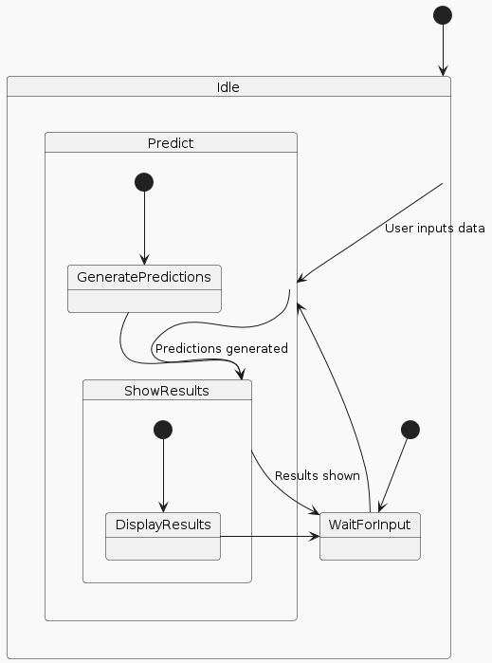

Figure 6.2: State transition diagram

### Design Constraints

* + - * Regulatory Compliance: The system must comply with healthcare data protection regulations such as HIPAA (Health Insurance Portability and Accountability Act) in the United States and GDPR (General Data Protection Regulation) in the European Union.
      * Data Privacy and Security: Patient data must be stored and trans- mitted securely, requiring robust encryption mechanisms. Secure au- thentication methods (e.g., multi-factor authentication) are required to prevent unauthorized access.
      * Performance and Scalability: The system should be able to handle a large number of concurrent users and large volumes of patient data without significant performance degradation.
      * Integration with Existing Systems: The system must integrate with ex- isting healthcare information systems (e.g., Electronic Health Records (EHR) systems) to import and export patient data.
      * Usability and Accessibility: The user interface must be designed to be user-friendly and accessible to users with varying levels of technical expertise.
      * Cost Constraints: Budgetary limitations may affect the choice of tech- nologies, infrastructure, and resources available for system development and maintenance. Cost-effective solutions and optimizations should be considered to ensure that the system remains within budget while meet- ing performance and functional requirements.
      * Maintenance and Upgradability: The system should be designed with maintainability in mind, allowing for easy updates and enhancements.
      * Data Quality and Consistency: Ensuring high data quality and con- sistency is critical for the accuracy of diabetes risk predictions. Data validation and cleansing mechanisms must be implemented to handle missing, incomplete, or inconsistent data.
      * Training and Support: Adequate training and support resources must be provided to ensure that users can effectively use the system

### Software Interface Description

Windows operating system will be used during the development process. System will be implemented using Python language. For data processing and feature selection ml Model is used. The required software requirements are given below:

|  |  |
| --- | --- |
| Software Product and Version | Source |
| Windows 11 | h[ttps://www.microsoft.com/soft](http://www.microsoft.com/software-)ware- download/windows11 |
| Python 3.12.0 | h[ttps://www.python.org/downloads/](http://www.python.org/downloads/) |
| VS Code | https://code.visualstudio.com/download |
| PIMA Dataset | h[ttps://www.kaggle.com/datasets/uciml/](http://www.kaggle.com/datasets/uciml/) pima-indians-diabetes-database |
| Scikit learn library | https://scikit-learn.org/stable/ |

# Chapter 7

**Detailed Design Document**

## Introduction

The project outlines the design requirements intended to address the dif- ficulties involved in diabetes prediction through the application of innova- tive machine learning methods. By employing a methodical design process, we define methods to efficiently fulfill the demands and goals of our un- dertaking. The details of our data structures, including internal, global, and temporary data structures, database design, and file formats, are ex- plained in the data design section. To ensure smooth data interchange and communication between software components, this also involves a thorough description of the data structures that are exchanged between them. This document offers a comprehensive structure for creating a solution that sat- isfies the particular requirements of our project by outlining the architec- tural design, data design, and other crucial elements. A number of machine learning techniques, including K-Nearest Neighbors (KNN), Random Forest, Support Vector Machine (SVM), and Decision Tree, will be integrated into a single, integrated ensemble model as part of the architectural design. Pre- processing techniques include handling missing values, feature scaling, and data splitting will be incorporated into the data design to make sure the data is ready for model training and assessment. The implementation of the XgBoost Classifier for model ensembling, along with the metrics and evalua- tion procedures employed, will also be covered in this project The proposed design, which promotes dependability and efficiency, attempts to clear the path for our project’s effective implementation and completion. By utilizing the advantages of each individual classifier, the ensemble model is antici- pated to increase prediction accuracy and offer a dependable and strong tool for diabetes diagnosis. This thorough design document acts as the project’s

51

blueprint, making sure that every part functions as a whole to meet our objective of improving diabetes prediction via machine learning.

## Architectural Design

The program architecture developed to solve the particular issue related to the product is described in the section on architectural design. It offers insights into how the software system is structured and how its many parts work together to produce the intended functionality.

Subsystem Design or Block Diagram:

Illustrates the various components or modules of the software system and their interconnections, offering a high-level overview of the system architecture and subsystem relationships.

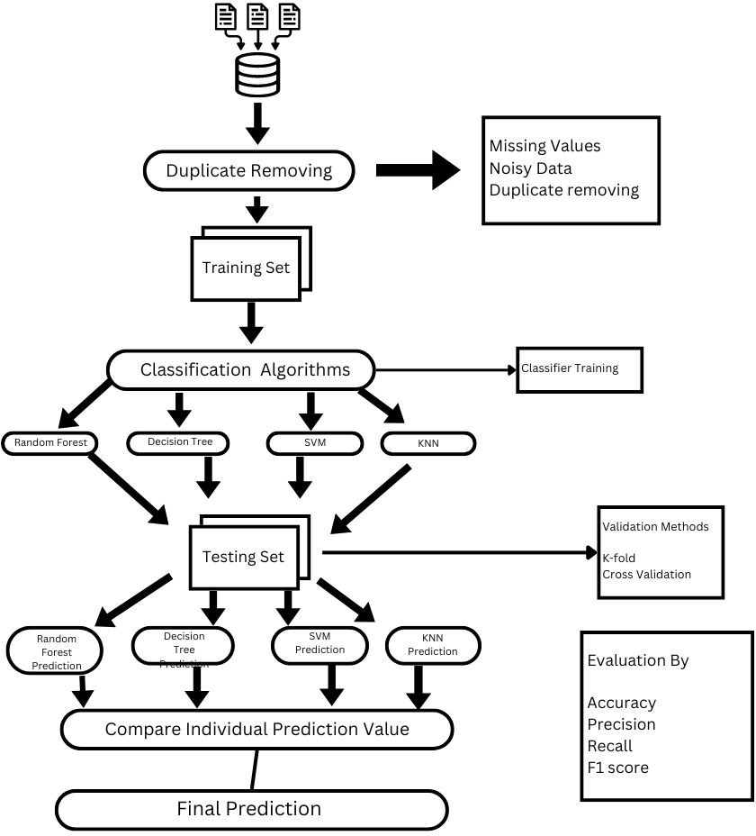Figure 7.1: Architecture diagram

* + - Use case Diagram:

The interactions between the diabetes prediction system and two ac- tors, ”User” and ”Admin,” are depicted in the use case diagram. While administrators have extra powers including uploading datasets and fresh patient data for analysis, users can obtain diabetes predictions, submit new patient data, and offer data for prediction.

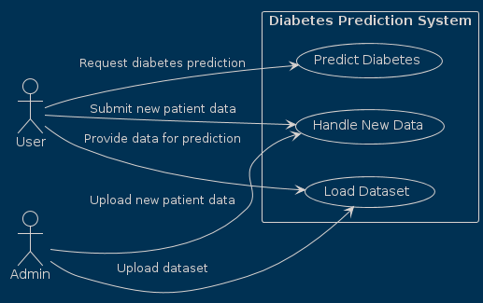

Figure 7.2: Use case diagram

* + - Activity Diagram:

Depicts the deployment of software components on hardware nodes or servers in a distributed computing environment, illustrating the physi- cal arrangement and interactions between software and hardware com- ponents.



Figure 7.3: activity diagram

## Component Design

A number of important components that are crucial to the system’s function- ing are encapsulated in the component design. Preprocessing the input data, which includes data cleansing, normalization, and feature extraction, is a cru- cial duty carried out by the DataProcessor component. It guarantees that the data is suitably prepared for additional analysis and model training, and it includes techniques for managing a variety of data formats. After that, utiliz- ing the preprocessed data, the ModelTrainer component oversees the training of machine learning models. Its features, which enable the development of reliable and accurate prediction models, include functions for model selec- tion, hyperparameter tuning, and performance evaluation. Using the trained models, the PredictionEngine component forecasts additional data inputs. It predicts if a person has diabetes by taking in input features, running them through trained algorithms, and producing prediction results. Furthermore, the UserInterface and AdminInterface components offer user-friendly inter- faces for data input, prediction requests, system management, and feedback reporting, respectively, tailored to the needs of users and administrators. By managing exception management and error logging, as well as by gathering and archiving crucial error data for debugging and troubleshooting, the Er- rorLogger component guarantees system resilience. These elements work in unison to achieve the system’s goals, coordinating a smooth and effective workflow inside the diabetes prediction

# Chapter 8

**Project Implementation**

## Introduction

The use of machine learning, especially in combination with ensemble tech- niques like Random Forest, SVM, and KNN, has shown great promise in predictive analytics, especially in the identification of medical conditions like diabetes. Even with these developments, there are still issues with improv- ing forecast precision and making the most use of processing power. With the help of a variety of machine learning techniques, we provide a thorough solution in this project to successfully handle these problems. The Ran- dom Forest, SVM, KNN, and Decision Tree algorithms are integrated in our method to create a strong ensemble model for diabetes prediction. Using feature engineering techniques to improve predictive capacities, increasing model performance through algorithmic fusion, and assessing the effective- ness of the ensemble model using real-world diabetes datasets are the main contributions of this work.When compared to individual algorithms, experi- mental evaluation shows significant improvements in computational efficiency and prediction accuracy. This project begins with a thorough explanation of the dataset, methods, and experimental findings. It ends with suggestions for further research.

55

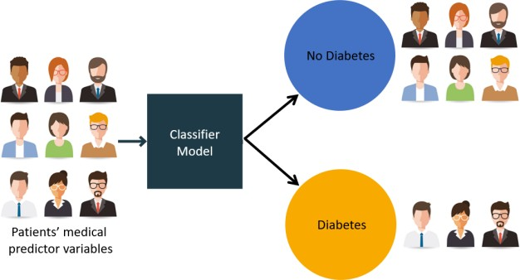Figure 8.1: Diabetes Classifier

## Tools and Technologies Used

* + - Development Tools: 1.Jupyter Notebook

An open-source web application that allows you to create and share

documents containing live code, equations, visualizations, and narra- tive text. It is widely used in data science and machine learning projects for interactive coding and exploratory data analysis.

* + - 2.Matplotlib

A plotting library for Python that provides a comprehensive set of functions and tools for creating various types of static, animated, and interactive visualizations. It is commonly used for data visualization and plotting graphs, charts, histograms, and more

* + - 3.Python:

A versatile and widely-used programming language known for its sim- plicity and readability. It offers extensive libraries and frameworks for

various applications, including web development, data analysis, ma- chine learning, and more. Python is the primary language used for your project

* + - 4.Sci-kit learn:

A popular machine learning library for Python. It provides a wide range of tools and algorithms for tasks such as data preprocessing, feature extraction, model selection, and model evaluation. Scikit-learn offers a user-friendly API and supports various machine learning techniques

* + - 5.Visual Studio Code (VSCode):

A lightweight yet powerful source code editor developed by Microsoft. It offers a rich set of features for code editing, debugging, version con- trol, and integrated terminal support. VSCode is highly extensible, supporting a wide range of programming languages and providing nu- merous extensions for customization

* + - 6. HTML

HTML (HyperText Markup Language) is the standard markup lan- guage for creating web pages and web applications. It provides the structure of a webpage, allowing developers to organize content into elements such as headings, paragraphs, links, images, and other mul- timedia. HTML is a cornerstone technology of the World Wide Web, working alongside CSS and JavaScript to create fully functional web- sites.

* + - 7. CSS

CSS (Cascading Style Sheets) is a stylesheet language used for describ- ing the presentation of a document written in HTML or XML. CSS defines how elements should be rendered on screen, on paper, or in other media. It allows developers to control layout, colors, fonts, and overall design, enabling the separation of content and design. This separation improves content accessibility, provides more flexibility and control in the specification of presentation characteristics, and enables multiple pages to share formatting by specifying the relevant CSS in a separate file.

* + - 8. PKL

PKL (Pickle) is a module in Python used for serializing and deserializ- ing Python object structures, also known as marshalling or flattening. The pickle module can transform a complex object into a byte stream

and convert the byte stream back into an object hierarchy. This is useful for saving program state data to a file so that it can be stored and later reloaded. It is commonly used in machine learning for saving trained models to disk.

* + - 9. Flask

Flask is a lightweight WSGI web application framework in Python. It is designed to make getting started quick and easy, with the ability to scale up to complex applications. Flask provides the tools, libraries, and technologies to build a web application. It is known for its sim- plicity, flexibility, and fine-grained control. Flask is often chosen for its modular design, allowing developers to pick and choose the components they need.

* + - 10. XGBoost

XGBoost (eXtreme Gradient Boosting) is an open-source software li- brary that provides a high-performance implementation of gradient boosting for machine learning. XGBoost is designed for speed and per- formance, and it implements machine learning algorithms under the Gradient Boosting framework. It provides parallel tree boosting (also known as GBDT, GBM), which helps to solve many data science prob- lems in a fast and accurate way. XGBoost is widely used in machine learning competitions and real-world applications due to its efficiency and accuracy.

## Methodologies/Algorithm Details

### Algorithm 1/Pseudo Code

#### K-nearest neighbor (KNN)

K-nearest neighbor (KNN) is a machine learning algorithm used for classification and regression analysis. Predictions are made by sim- ilarity between input and training data. Algorithm :Let the training dataset be (x1, y1),(x2, y2), ...,(x m, ym) where m is the total number of data points.1. Choose a value for K. 2. Choose a similarity mea- sure to be used for K number of neighbours. Some of the most used similarity measures are: (a) Minkowski Distance: article amsmath The Minkowski distance between two points *x* and *y* in *n*-dimensional space

is given by:

*p*

*d*(*x, y*) =

*n i*=1

*|xi − yi|*

!1*/p*

where *x* = (*x*1*, x*2*, . . . , xn*) and *y* = (*y*1*, y*2*, . . . , yn*) are the coordinates of the two points, and *p* is a positive real number representing the order of the Minkowski distance. b)Eucleadian Distance The Euclidean distance between two points (*x*1*, y*1) and (*x*2*, y*2) in a two-dimensional space is given by:

Σ

*d* = q(*x*2 *− x*1)2 + (*y*2 *− y*1)2

3. As per the similarity measure choose the nearest K points. 4. Among the K selected points count the number of points lying in each category. 5. The category which has the highest count is the category

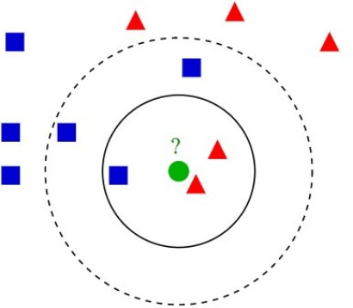to which the new data point shall belong to. 6. The KNN classification model is now ready.

Figure 8.2: Using KNN to Classify new points

#### Decision Tree Classifier

* A decision tree classifier works by building a tree-like model of decisions and their possible outputs. Until a stopping condition is meet recursive splitting of data into subsets based on the values of the features takes place. Various Decision Tree Algorithms :
  + The ID3 (Iterative Dichotomiser 3) algorithm creates a multiway tree and employs a greedy approach to identify the category charac- teristic at each node that will produce the most information gain for

categorical targets. To enhance a tree’s capacity to generalize to new data, trees are typically pruned after reaching their maximum size.

* + The successor to ID3 is C4.5, which removes the requirement that features be categorical by dynamically generating a discrete attribute (based on numerical variables) that divides the continuous attribute value into a discrete set of intervals.
  + C5.0 is the most recent version released by Quinlan under a pro- prietary license. Compared to C4.5, it creates smaller rulesets and uses less memory while yet being more precise.
    - * 1. Tree Building: The first phase is tree building, which entails recursively separating nodes to create a tree. Using the class distribu- tion observed in the learning dataset for a particular node, along with the decision cost matrix, a predicted class is assigned to each resulting node.
        2. Stopping Tree Building: The second stage is to halt the growth of the trees. Currently, a ”maximal” tree has been created, which likely considerably overfits the data from the learning dataset.
        3. Tree Pruning: The third phase is tree pruning, which involves chopping off more significant nodes to produce a succession of ever simpler trees. “Cost-complexity” pruning method is implemented.
        4. Optimal Tree Selection: The fourth stage is optimal tree selec- tion, in which a tree is chosen from a succession of pruned trees that best fits the data in the learning dataset while avoiding overfitting it.

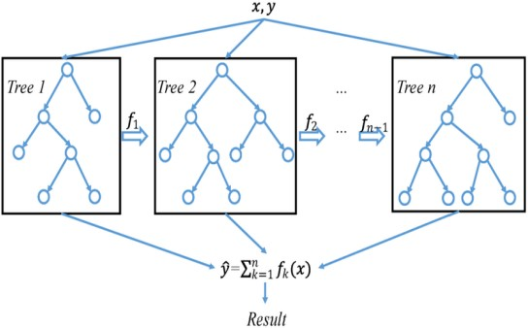Figure 8.3: Decision Tree Diagram

#### Random Forest Classifier

Random Forest is a collection of decision trees that are trained on dif- ferent subsets of the training data using random feature subsets, this is called as ensemble learning. The ultimate prediction is derived by aggregating the individual predictions from each decision tree. Mathe- matically it is defined as: h (x, k), k = 1, . . . , L where, x is the input data and k is vector parameter that is mutually independent among the decision trees.

* Algorithm Let k denotes the number of decision trees in the random forest, n denotes the number of training samples for each decision tree, M stands for the sample’s feature count; it is the quantity of features used for segmentation on a single decision tree node, M m.
  + - * 1. Generate a training set consisting of k groups by repeatedly sampling N times from all available training samples using bootstrap sampling. For each training set, construct a decision tree using samples drawn randomly from the k group data, considering only the samples that were not included (Out Of Bag - OOB samples).
        2. At each node of the decision tree, select m features and evaluate the best splitting criteria based on these m features.
        3. Allow each decision tree to grow.
        4. Combine all the decision trees to create a random forest model. Ensemble techniques are used in Random Forest to combine the pre- dictions of multiple decision trees, thereby improving the accuracy and robustness of the model. The main ensemble techniques used in Ran- dom Forest is XgBoost

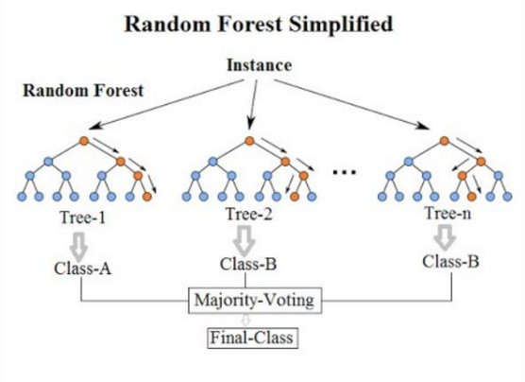

Figure 8.4: Random Forest Diagram

### XgBoost

XgBoost (eXtreme Gradient Boosting) is an open-source machine learn- ing library that implements the gradient boosting framework for high performance and efficiency. It excels in speed due to parallel process- ing and optimized memory usage, and it handles large-scale data effec- tively. XGBoost’s flexibility allows for custom objective functions and supports various programming languages, making it ideal for diverse machine learning tasks. Widely used in competitions and real-world applications, it is known for its high accuracy and robust handling of missing data. Additionally, it includes L1 and L2 regularization to prevent overfitting, supports tree pruning to simplify models, and introduces a learning rate to enhance model performance. Despite its complexity and need for hyperparameter tuning, its scalability and pre- dictive power make it a favored tool among data scientists.

## Verification and Validation for Accep- tance

### Experimental Results on Dataset 1

|  |  |  |  |  |
| --- | --- | --- | --- | --- |
| Algorithms | Accuracy | Precision | Recall | F1 Score |
| KNeighboursClassifier() | 69 | 72 | 86 | 79 |
| SVM | 78 | 77 | 91 | 83 |
| Decision Tree | 68 | 74 | 81 | 77 |
| Random Forest | 72 | 76 | 84 | 80 |
| XgBoost | 75 | 81 | 81 | 81 |

Table 8.1: Experimental Results on Dataset 1

* The SVM classifier has the maximum accuracy of 78 percent and a good F1 Score of 83, suggesting its efficacy in differentiating between instances that are diabetic and those that are not, according to the ex- perimental data from our diabetes prediction study. With an accuracy

of 72percent and an F1 Score of 80, the Random Forest classifier like- wise exhibits strong performance, indicating a well-balanced trade-off between recall and precision. With an accuracy of 69 percent and an F1 Score of 79, the KNeighborsClassifier performs moderately, demon- strating its dependability in this situation. With an accuracy of 68 percent and an F1 Score of 77, the Decision Tree classifier, in contrast, performs comparably but marginally less well than the Random For- est and SVM models.XGBoost demonstrates itself as a strong model with competitive precision and recall values, achieving an accuracy of 75 percent and an F1 Score of 81.

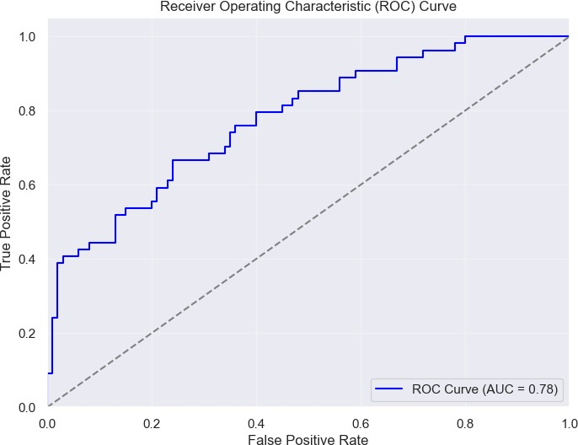Figure 8.5: ROC Curve for SVM

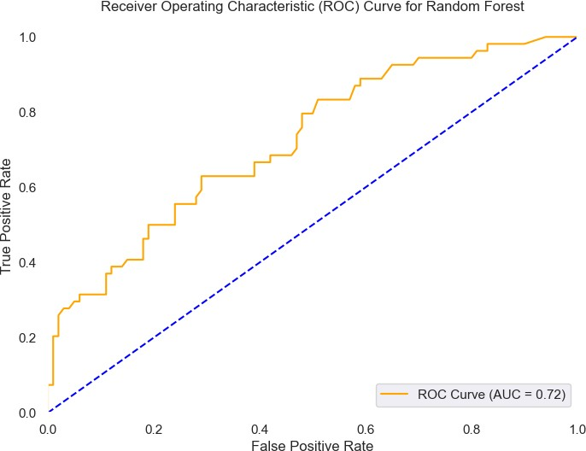Figure 8.6: ROC Curve for Random Forest

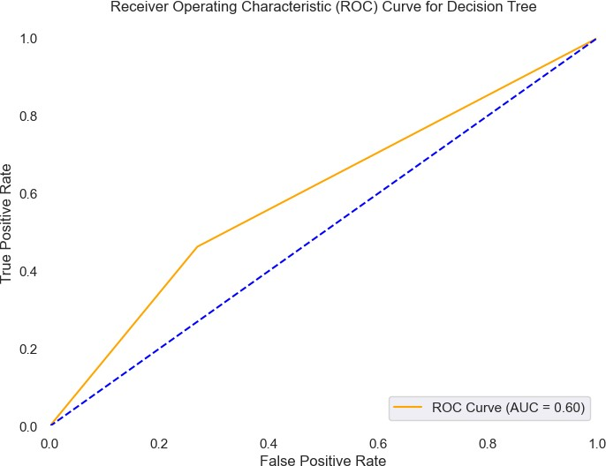Figure 8.7: ROC Curve for Decision Tree

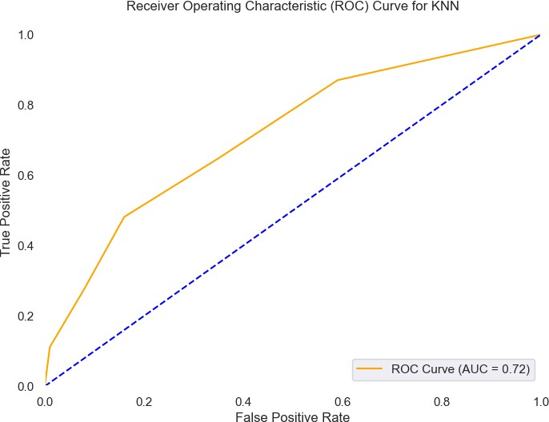Figure 8.8: ROC Curve for KNN

### Experimental Results on Dataset 2

|  |  |  |  |  |
| --- | --- | --- | --- | --- |
| Algorithms | Accuracy | Precision | Recall | F1 Score |
| KNeighboursClassifier() | 69 | 60 | 39 | 47 |
| SVM | 76 | 75 | 50 | 60 |
| Decision Tree | 68 | 57 | 46 | 51 |
| Random Forest | 72 | 63 | 50 | 53 |
| XgBoost | 75 | 65 | 65 | 65 |

Table 8.2: Experimental Results on Dataset 2

* The SVM classifier has the best accuracy at 76 and an F1 Score of 60 based on the experimental results from Dataset 2, demonstrating a balanced performance in differentiating between instances with and without diabetes. With a steady F1 Score of 65 and an accuracy of 75, the XGBoost model exhibits strong performance and dependability. It trails the competition closely. With an accuracy of 72 and an F1 Score of 53, the Random Forest classifier likewise exhibits a mediocre level of performance, exhibiting a respectable equilibrium between recall and precision.

### Result Analysis

* A comparison of the models’ performance on Datasets 1 and 2 high- lights a number of important findings. Notably, when comparing Dataset 2 to Dataset 1, all models’ accuracy has dropped. This is to be ex- pected, as accurate classification becomes more difficult with larger Dataset 2 due to its increased complexity and possible noise. For in- stance, the SVM classifier’s accuracy decreased to 76 on Dataset 2 from its maximum of 78 on Dataset 1. The accuracy of Random Forest also declined, from 72 to 72, demonstrating how dataset complexity affects model performance.
* The majority of models’ accuracy values stayed mostly unchanged be- tween the two datasets. For Datasets 1 and 2, the Random Forest classifier consistently maintained a precision of 76 and 63, respectively. Consistent precision values were likewise displayed by the KNN and Decision Tree classifiers. On Dataset 2, however, the SVM and XG- Boost classifiers saw a slight drop in precision, which may have been caused by the larger dataset’s higher unpredictability and complexity.
* On Dataset 2, all models’ recall values dropped, suggesting a decline in their ability to detect true positives. For example, on Dataset 2, the SVM classifier’s recall decreased from 91 to 50. Because there was more non-diabetic data in Dataset 2, it was more difficult to identify the minority class of diabetic cases. This pattern persisted across all classifiers.

The results of the F1 Score, which weighs recall and precision equally, likewise differed between the datasets. On Dataset 2, the SVM and Random Forest classifiers, which had previously achieved high F1 Scores of 83 and 80 on Dataset 1, were reduced to 60 and 53. Remarkably, the F1 Score improved somewhat from 81 according to the XGBoost model on Dataset 1 to 65 on Dataset 2, demonstrating its resilience in preserving the equilibrium between recall and precision in spite of the growing complexity of the dataset.

* Overall, the findings show that classifier performance tends to decline with increasing dataset size and complexity. While showing a notice- able decline in performance on Dataset 2, the Random Forest and SVM models—which had done well on Dataset 1—kept their relatively decent accuracy and F1 Scores. On the bigger dataset, the KNN and Decision Tree models showed comparable patterns in terms of decreased recall and F1 Scores. Despite being impacted by the increasingly complicated dataset, the XGBoost model proved to be a dependable option for this task because it could balance recall and precision.

# Chapter 9 Software Testing

## Type of Testing Used

* + - Unit Testing
    - Integration Testing
    - System Testing

67

## Test Cases and Test Results

### Unit Testing:

Test case Description: Verify that the data preprocessing function cor- rectly handles missing values and normalizes the data.

Input: Raw dataset with missing values.

Expected Output: Dataset with imputed missing values and normal- ized features.

Result: Passed

Comments: The function correctly handled missing values by replacing them with the mean and normalized the data as expected.

### Integration Testing:

Test case Description: Verify the data flows correctly from the pre- processing component to the model training component. Input: Raw dataset. Expected Output: Trained model. Result: Passed Comments: Data was correctly preprocessed and passed to the model training func- tion, resulting in a trained model.

### System Testing

Test Case : End-to-End System Test : Verify the complete system from data input through the UserInterface to prediction output. Input: User-provided data via the interface. Expected Output: Prediction result displayed to the user. Result: Passed : The system successfully processed the input, generated a prediction, and displayed the result to the user.

MESWCOE, Department of Computer Engineering 2023-2024

# Chapter 10 Results

## Implementation snapshot

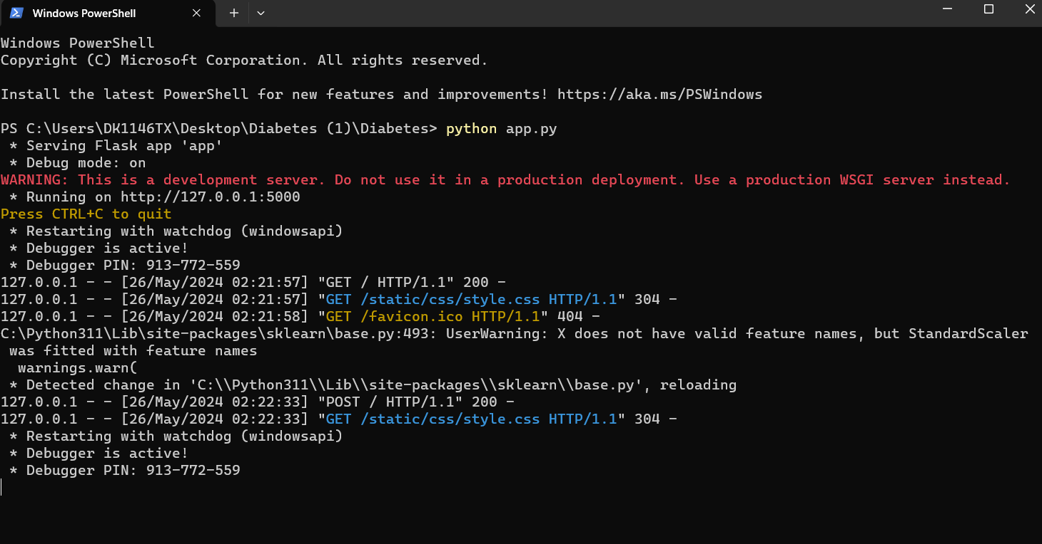

Figure 10.1: Terminal Command for execution

•

Launching the project is facilitated by the terminal interface, which shows the necessary command ”python app.py” that initiates the Diabetic predictor application. The program interface appears when it is invoked, providing a platform that is easy to use for diabetes prognosis. Critical variables that are essential for assessing the risk of diabetes are prominently displayed in this graphical user interface (GUI). These attributes include

69

blood pressure, pregnancy status, insulin level, skin thickness, and glucose level. By entering pertinent data into the designated fields, users can interact with this user-friendly interface.

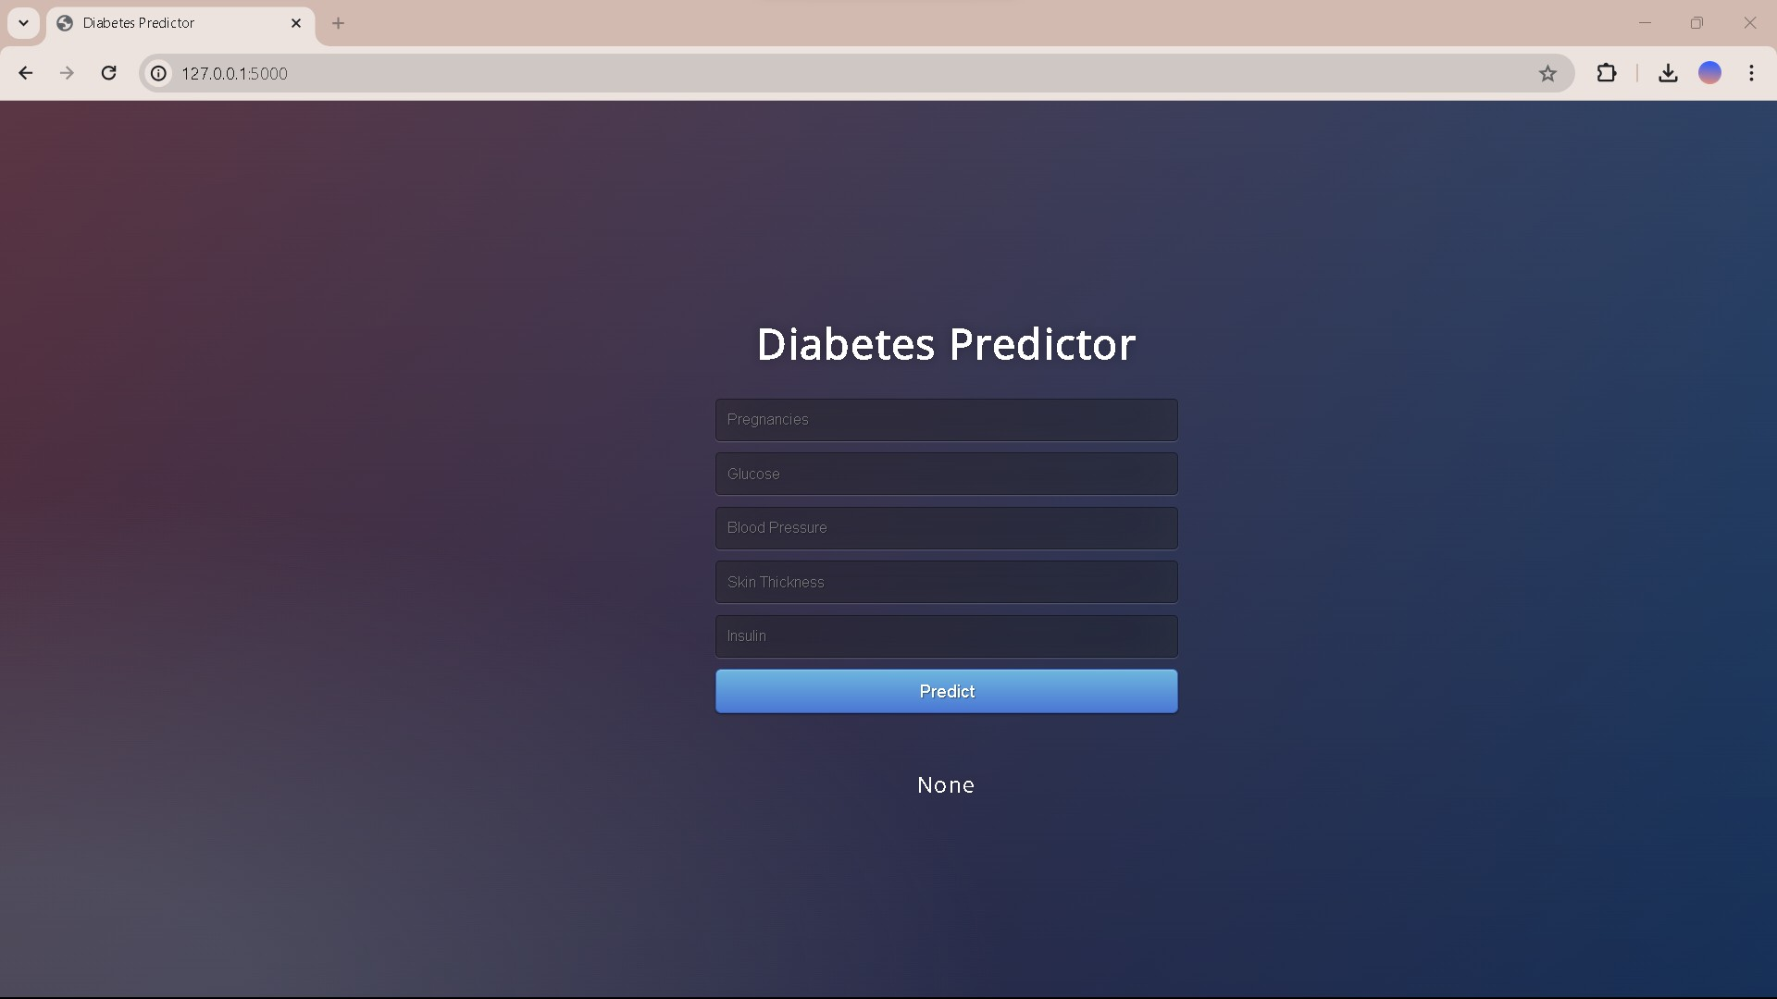

Figure 10.2: Home Page

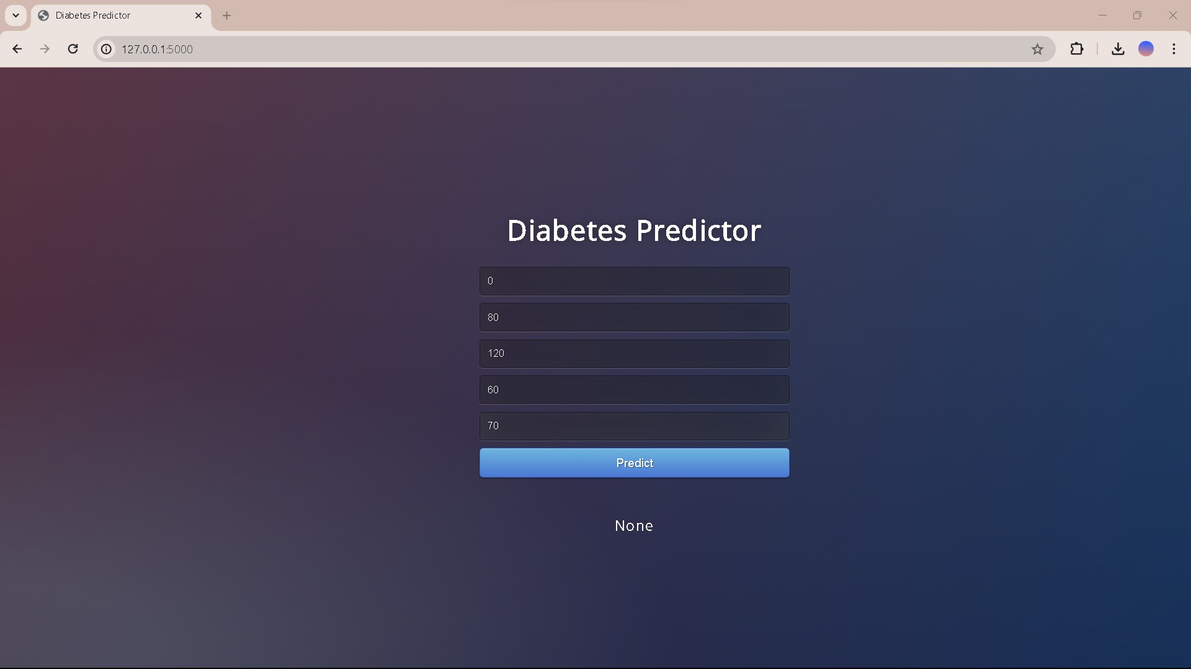

Figure 10.3: Input

After entering all the necessary data, users instruct the application to use the complex algorithms built into the system to calculate the predicted result. The program uses machine learning algorithms in the background to perform a thorough analysis of the input data. After the calculation is

complete, the program instantly provides users with diagnostic information about their diabetes risk. Users can make well-informed decisions about their well-being with the help of this actionable feedback, which gives them insightful information about their current health.

Incorporating a terminal interface also expedites the project execution process by giving users a quick and easy way to start the program. The com- mencement procedure is made simpler by the terminal’s concise command format, which guarantees a smooth user experience.

## Output

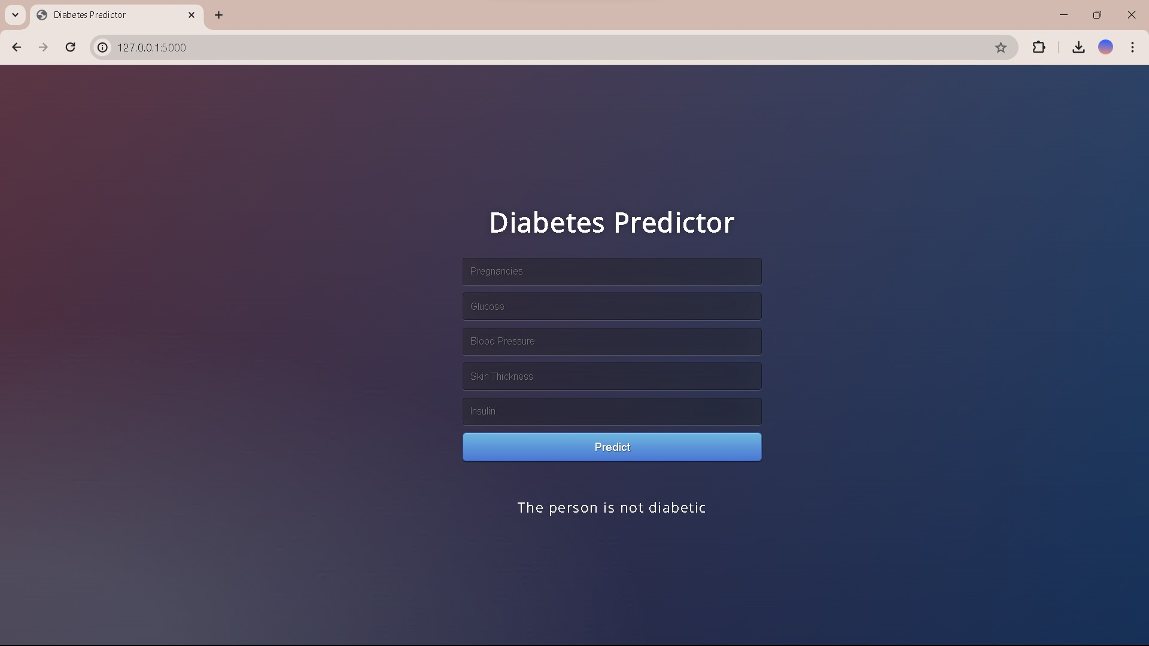

Figure 10.4: Result for given input

An essential diagnostic result from the Diabetic Predictor application indicates if a person has diabetes or not. The application’s complex computa- tional procedures and cutting-edge machine learning algorithms are respon- sible for this outcome. The result makes it easier to make judgments about one’s health because it provides a conclusive evaluation of the person’s dia- betes state. Based on these succinct and straightforward diagnostic results, users can take proactive measures to address any health risks related to dia- betes. The program remains as successful at providing users with actionable insights on their health state even in the absence of generated screenshots.

# Chapter 11

**Conclusion and future scope**

The Pima Indians Diabetes dataset research highlights how important feature engineering, thorough data preprocessing, and rigorous model evaluation are to creating predictive models that are reliable. Important preprocessing pro- cedures included dealing with missing values and fixing inaccurate data, and feature engineering included new features like ”Glucose Result” and ”Nutri- tional Status” that provided insightful new information. The Support Vector Machine (SVM) with a linear kernel proved to be the most successful of the studied methods, exhibiting the highest accuracy and a robust capacity to generalize to new data. By concentrating on the most crucial characteristics, Recursive Feature Elimination with Cross-Validation (RFECV) improved the model’s performance even more.

To increase model accuracy, future research should use more sophis- ticated feature engineering methods and new datasets, such as genetic data and lifestyle characteristics. Improved predictive models may result from investigating more deep learning and machine learning algorithms, such as neural networks and ensemble methods. In order to earn the trust of patients and healthcare professionals, real-world deployment will need to handle ethi- cal considerations, data protection issues, and guarantee model openness and interpretability. Maintaining the model’s correctness and relevance requires constant observation and updating with fresh data, underscoring the signifi- cance of continued study and advancement in this area. Adding a feedback loop to enable ongoing learning from fresh cases would improve the predictive power of the model even more. This guarantees that the model is updated with the most recent medical knowledge, resulting in forecasts that are more accurate and trustworthy. Sustaining progress in this domain is essential for enhancing diabetes control and patient results.

# Annexure A References

1. Hamza, Lena abed ALraheim; Lafta, Hussein Attya; and Al-Rashid, Sura Zaki (2023) ”Predictive Diabetes Mellitus From DNA Sequences Using Deep Learning,” Al-Bahir Journal for Engineering and Pure Sciences: Vol. 3: Iss. 2, Article 3. Available at: https://doi.org/10.55810/2313-0083.1042
2. Zou Q, Qu K, Luo Y, Yin D, Ju Y and Tang H (2018) Predict- ing Diabetes Mellitus With Machine Learning Techniques. Front. Genet. 9:515. https://doi.org/10.3389/fgene.2018.00515
3. Das, B. A deep learning model for identification of diabetes type 2 based on nucleotide signals. Neural Comput Applic 34, 12587–12599 (2022). https://doi.org/10.1007/s00521-022-07121-8
4. Kim J, Kim J, Kwak MJ, Bajaj M. Genetic prediction of type 2 diabetes using deep neural network. Clin Genet. 2018 Apr;93(4):822-829. doi: 10.1111/cge.13175. Epub 2018 Feb 20. PMID: 29136281.
5. H. Alshamlan, H. B. Taleb and A. Al Sahow, ”A Gene Predic- tion Function for Type 2 Diabetes Mellitus using Logistic Regression,” 2020 11th International Conference on Information and Communication Systems (ICICS), Irbid, Jordan, 2020, pp. 1-4, doi: 10.1109/ICICS49469.2020.239549.
6. Atul Kumar, D. Jeya Sundara Sharmila, Sachidanand Singh,SVMRFE based approach for prediction of most discriminatory gene target for type II diabetes,Healthcare Data, Volume 12,2017,Pages 28-37,ISSN 2213-5960, https://doi.org/10.1016/j.gdata.2017.02.008.
7. Lello L, Raben TG, Yong SY, Tellier LCAM, Hsu SDH. Health- care Prediction of 16 Complex Disease Risks Including Heart Attack, Dia- betes, Breast and Prostate Cancer. Sci Rep. 2019 Oct 25;9(1):15286. doi: 10.1038/s41598-019-51258-x. Erratum in: Sci Rep. 2019 Nov 20;9(1):17515. PMID: 31653892; PMCID: PMC6814833.
8. Loh M, Zhang W, Ng HK, Schmid K, Lamri A, Tong L, Ahmad M, Lee JJ, Ng MCY, Petty LE, Spracklen CN, Takeuchi F, Islam MT, Jasmine

F, Kasturiratne A, Kibriya M, Mohlke KL, Par´e G, Prasad G, Shahriar M, Chee ML, de Silva HJ, Engert JC, Gerstein HC, Mani KR, Sabanayagam C, Vujkovic M, Wickremasinghe AR, Wong TY, Yajnik CS, Yusuf S, Ahsan H, Bharadwaj D, Anand SS, Below JE, Boehnke M, Bowden DW, Chandak GR, Cheng CY, Kato N, Mahajan A, Sim X, McCarthy MI, Morris AP, Kooner JS, Saleheen D, Chambers JC. Identification of genetic effects underlying type 2 diabetes in South Asian and European populations. Commun Biol. 2022 Apr 7;5(1):329. doi: 10.1038/s42003-022-03248-5. Erratum in: Commun Biol. 2022 May 5;5(1):441. PMID: 35393509; PMCID: PMC8991226.

1. Diabetes Genetics Initiative of Broad Institute of Harvard and MIT, Lund University, and Novartis Institutes of BioMedical Research; Saxena R, Voight BF, Lyssenko V, Burtt NP, de Bakker PI, Chen H, Roix JJ, Kathire- san S, Hirschhorn JN, Daly MJ, Hughes TE, Groop L, Altshuler D, Almgren P, Florez JC, Meyer J, Ardlie K, Bengtsson Bostr¨om K, Isomaa B, Lettre G, Lindblad U, Lyon HN, Melander O, Newton-Cheh C, Nilsson P, Orho- Melander M, R˚astam L, Speliotes EK, Taskinen MR, Tuomi T, Guiducci C, Berglund A, Carlson J, Gianniny L, Hackett R, Hall L, Holmkvist J, Laurila E, Sj¨ogren M, Sterner M, Surti A, Svensson M, Svensson M, Tewhey R, Blu- menstiel B, Parkin M, Defelice M, Barry R, Brodeur W, Camarata J, Chia N, Fava M, Gibbons J, Handsaker B, Healy C, Nguyen K, Gates C, Sougnez C, Gage D, Nizzari M, Gabriel SB, Chirn GW, Ma Q, Parikh H, Richardson D, Ricke D, Purcell S. Genome-wide association analysis identifies loci for type 2 diabetes and triglyceride levels. Science. 2007 Jun 1;316(5829):1331-6. doi: 10.1126/science.1142358. Epub 2007 Apr 26. PMID: 17463246.
2. Cai L, Wheeler E, Kerrison ND, Luan J, Deloukas P, Franks

PW, Amiano P, Ardanaz E, Bonet C, Fagherazzi G, Groop LC, Kaaks R, Huerta JM, Masala G, Nilsson PM, Overvad K, Pala V, Panico S, Rodriguez- Barranco M, Rolandsson O, Sacerdote C, Schulze MB, Spijkerman AMW, Tjonneland A, Tumino R, van der Schouw YT, Sharp SJ, Forouhi NG, Ri- boli E, McCarthy MI, Barroso I, Langenberg C, Wareham NJ. Genome-wide association analysis of type 2 diabetes in the EPIC-InterAct study. Sci Data. 2020 Nov 13;7(1):393. doi: 10.1038/s41597-020-00716-7. PMID: 33188205; PMCID: PMC7666191.

1. Cole JB, Florez JC. Genetics of diabetes mellitus and diabetes com- plications. Nat Rev Nephrol. 2020 Jul;16(7):377-390. doi: 10.1038/s41581- 020-0278-5. Epub 2020 May 12. PMID: 32398868; PMCID: PMC9639302.
2. Cho NH et al. IDF Diabetes Atlas: Global estimates of diabetes prevalence for 2017 and projections for 2045. Diabetes Res. Clin. Pract 138, 271–281, doi: 10.1016/j.diabres.2018.02.023 (2018). [PubMed] [CrossRef] [Google Scholar]
3. Butt UM, Letchmunan S, Ali M, Hassan FH, Baqir A, Sherazi

HHR. Machine Learning Based Diabetes Classification and Prediction for Healthcare Applications. J Healthc Eng. 2021 Sep 29;2021:9930985. doi: 10.1155/2021/9930985. PMID: 34631003; PMCID: PMC8500744.

1. Oliullah, K., Rasel, M.H., Islam, M.M. et al. A stacked ensemble machine learning approach for the prediction of diabetes. J Diabetes Metab Disord (2023). https://doi.org/10.1007/s40200-023-01321-2
2. TY - BOOK AU - Tripathi, Deeksha AU - Biswas, Saroj AU - S., Reshmi AU - Nath Boruah, Arpita AU - Purkayastha, Biswajit PY - 2022/08/26 SP - 1 EP - 7 T1 - Diabetes Prediction Using Machine Learn- ing Analytics: Ensemble Learning Techniques VL - DO - 10.1109/ASIAN- CON55314.2022.9908975 ER -
3. TY - JOUR AU - Nagpal, Anisha AU - Sabharwal, Munish AU - Tripathi, Rohit PY - 2023/09/10 SP - 2024031 T1 - A novel ensemble machine learning framework for early stage diabetes mellitus prediction VL - 6 DO - 10.31893/multiscience.2024031 JO - Multidisciplinary Science Journal
4. National Diabetes Statistics Report — Diabetes — Centers for Dis-

ease Control and Prevention. 2022. h[ttps://www.cdc.go](http://www.cdc.gov/diabetes/data/statistics-)v/diab[etes/data/statistics-](http://www.cdc.gov/diabetes/data/statistics-) report/index.html. Accessed 25 Jan 2023

1. Hosseini Sarkhosh SM, Esteghamati A, Hemmatabadi M, Daraei

M. Predicting diabetic nephropathy in type 2 diabetic patients using machine learning algorithms. J Diabetes Metab Disord. 2022;21(2):1433–41.

1. Hemanth S, Alagarsamy S. Hybrid adaptive deep learning classifier for early detection of diabetic retinopathy using optimal feature extraction and classification. J Diabetes Metab Disord. 2023:1–15
2. Bukhari MM, Alkhamees BF, Hussain S, Gumaei A, Assiri A, Ullah SS. An improved artificial neural network model for effective diabetes prediction. Complexity. 2021;2021:1–10.
3. R. Williams, S. Karuranga, B. Malanda et al., “Global and re- gional estimates and projections of diabetes-related health expenditure: re- sults from the international diabetes federation diabetes atlas,” Diabetes Re- search and Clinical Practice, vol. 162, Article ID 108072, 2020.
4. American Diabetes Association, “Diagnosis and classification of di- abetes mellitus,” Diabetes Care, vol. 37, no. Supplement 1, pp. S81–S90, 2014.

[23]G. Acciaroli, M. Vettoretti, A. Facchinetti, and G. Sparacino, “Cal-

ibration of minimally invasive continuous glucose monitoring sensors: state- of-the-art and current perspectives,” Biosensors, vol. 8, no. 1, 2018.

1. N. N. Tun, G. Arunagirinatha, S. K. Munshi, and J. M. Pappachan, “Diabetes mellitus and stroke: a clinical update,” World Journal of Diabetes, vol. 8, no. 6, 2017.
2. M. J. Davies, D. A. D’Alessio, J. Fradkin et al., “Management of

hyperglycaemia in type 2 diabetes, 2018. a consensus report by the American diabetes association (ada) and the european association for the study of diabetes (easd),” Diabetologia, vol. 61, no. 12, pp. 2461–2498, 2018.

1. D. Bruen, C. Delaney, L. Florea, and D. Diamond, “Glucose sens- ing for diabetes monitoring: recent developments,” Sensors, vol. 17, no. 8, 2017.
2. S. Wadhwa and K. Babber, “Artificial intelligence in health care: predictive analysis on diabetes using machine learning algorithms,” in Pro- ceeding of the International Conference on Computational Science and Its Applications, pp. 354–366, Springer, Cagliari, Italy, July 2020.

[28]D. Sisodia and D. S. Sisodia, “Prediction of diabetes using classi- fication algorithms,” Procedia computer science, vol. 132, pp. 1578–1585, 2018

[29] N. Pradhan, G. Rani, V. S. Dhaka, and R. C. Poonia, “Diabetes prediction using artificial neural network,” Deep Learning Techniques for Biomedical and Health Informatics, Springer, Singapore, pp. 327–339, 2020. [30]B. He, K.-i. Shu, and H. Zhang, “Machine learning and data mining

in diabetes diagnosis and treatment,” in Proceeding of the IOP Conference Series: Materials Science and Engineering, May 2019.

[31]G. A. Pethunachiyar, ”Classification Of Diabetes Patients Using Kernel Based Support Vector Machines,” 2020 International Conference on Computer Communication and Informatics (ICCCI), Coimbatore, India, 2020, pp. 1-4, doi: 10.1109/ICCCI48352.2020.9104185. keywords: Support vec- tor machines;Machine learning algorithms;Machine learning;Prediction algo-

rithms;Diabetes;Classification algorithms;Kernel;Diabetes;Kernel;Linear;Machine Learning;Support Vector Machines,

# Annexure B Project Planner



Figure B.1: Project Planner Gantt Chart

The project kickstarts with a two-day kickoff that allows for prelimi- nary planning and preparation. The next four days are devoted to thoroughly comprehending the issue statement, and the next seven days are spent ac- quiring datasets and establishing the requirements for the problem. Four days are spent writing the literature review, which allows for thorough in- vestigation and analysis. One of the most important steps—whose time is unknown—is creating UML diagrams. The review paper draft process takes a long time—31 days—to guarantee careful inspection and improvement. The next steps of developing the model and putting it into practice take a lot of time—57 days and 53 days, respectively. Finally, even though the time frame isn’t stated, testing the generated solution is essential to guaranteeing its functioning and dependability.

# Annexure C

**Reviewers Comments of Paper Submitted**

1. Paper Title:Novel Ensembled Approach To Healthcare Data
2. Name of the Conference/Journal where paper submitted :International Journal of Innovative Research in Computer and Communication En- gineering (IJIRCCE)
3. Paper accepted/rejected : Accepted
4. Corrective actions if any : NA

# Chapter 4

**Information of Project Group Members**

.



* 1. **Name**: Kunal Ganpat Digole
  2. **Date of Birth**: 22/06/2001
  3. **Gender**: Male
  4. **Permanent Address**: Bhagya nagar, Gan- gakhed, Dist.Parbhani 431514
  5. **E-Mail**: [kunal.digole94@gmail.com](mailto:kunal.digole94@gmail.com) (f) **Mobile/Contact No.**: 9767297788

1. **Placement Details**: Not placed
2. **Paper Published**: Yes
3. **Name**: Sakshi Niraj Birajdar
4. **Date of Birth**: 12/08/2002
5. **Gender**: Female
6. **Permanent Address**: ’Kashi Kunj’ Niwas Wale Nagar, Latur
7. **E-Mail**: [sakshibira](mailto:sakshibirajdar12@gmail.com)[jdar12@gmail.com](mailto:jdar12@gmail.com) (f) **Mobile/Contact No.**: 9511978234

#### Placement Details: -

1. **Paper Published**: Yes



1. **Name**: Hemant Maknar
2. **Date of Birth**: 26/02/2002
3. **Gender**:Male
4. **Permanent Address**:Flat No G - 201,

Parksyde Homes, Panchavati, Nashik

1. **E-Mail**: [hemantmank](mailto:hemantmankar007@gmail.com)[ar007@gmail.com](mailto:ar007@gmail.com) (f) **Mobile/Contact No.**: 9881608253

#### Placement Details: -

1. **Paper Published**: yes



1. **Name**:Rutuj Gangawane
2. **Date of Birth**:24/05/2002
3. **Gender**:Male
4. **Permanent Address**:Flat No A - 3, Sai preetam park, Vijaynagar, Kalewadi,

Pimpri-Chinchwad , Pune

1. **E-Mail**: [rutuj.02gangaw](mailto:rutuj.02gangawane@gmail.com)[ane@gmail.com](mailto:ane@gmail.com) (f) **Mobile/Contact No.**: 9422005368

#### Placement Details: -

1. **Paper Published**: Yes